

**QUIZ PRACTICE SYSTEM**

**Software Requirement Specification**

– Hanoi, May 2022 –

I. Overview

1. Introduction

2. System Functions

3. Common Requirements

II. Functional Requirements   
 1. Feature Common

a. Login

b. Register

c. Reset Password

d. User Authorization

e. User Profile

f. Change Password

2. Feature Public

a. [Home (Landing page)](https://docs.google.com/document/d/1QE98nRebuO_29eRAOJ6XhIBVfDYjzzeu/edit#heading=h.35nkun2)

b. Quiz List

c. Quiz Details

d. Subjects List  
e. Subject Details

3. Feature Student

a. Practices List  
b. Quiz Handle

c. Quiz Review

4. Feature Expert

a. Quiz List  
b. Question List

5. Feature Admin

a. Management Question  
b. Management Quiz  
d. Management Subject  
f. Management User

# I. Overview

## 1. Introduction

The purpose of this project is to create a website that is used to practice or test knowledge of subjects as well as social knowledge through multiple choice answers. The multiple-choice questions in Quiz are in many categories with different levels for students to try, assess their own level or teachers can access quizzes shared by others, as well as create quizzes. tests for use in teaching. The site is suitable for both home and classroom learning.

## 2. System Functions *a. Context Diagram*

#### b. Screen Flow

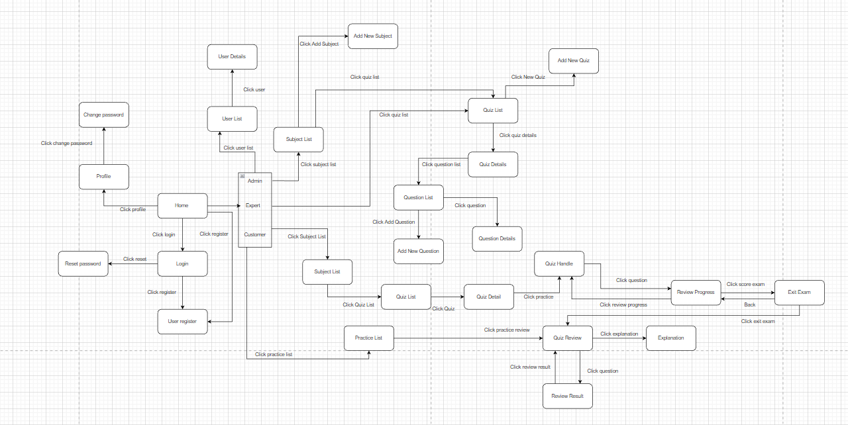  
  
***c. ERD Diagram***  
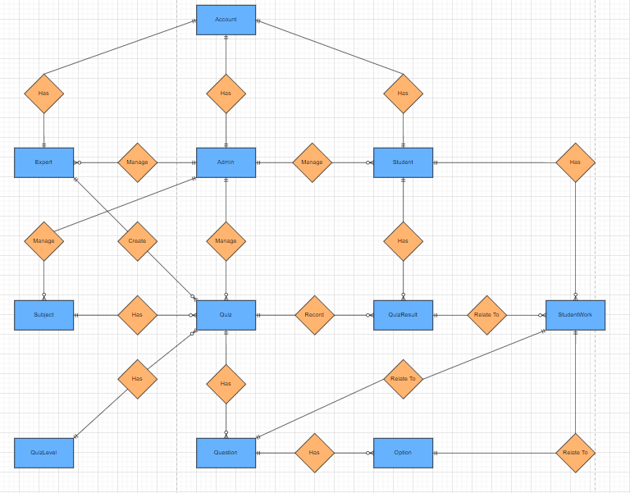

#### d. Screen Details

| **#** | **Function/Screen** | **Feature** | **Function/Screen Details** |
| --- | --- | --- | --- |
| 1 | User Login | Common | This is the screen when the user pops up allowing the user to enter an email and password to log in, on the page, there are also options for the user to register a new account, reset the password in case of forgetting. |
| 2 | User Register | Common | This screen allows the user to sign up for an account by entering the following information: username, email, password, confirm password, dob, and gender. After that, the user needs to verify by entering the code that the system sent via email to confirm. |
| 3 | Reset Password | Common | The user of this screen enters his email to receive a random code, then goes to the page to check the code entered, if check successfully to the page to change the password, and then will enter a new password. |
| 4 | User Authorization | Common | Implementation of authorization mechanism in the system, including the specify the role of logged-in user, his/her authorized page links (building the displayed menu items (in the front end) and preventing unauthorized access via entering the links directly) |
| 5 | User Profile | Common | This is a pop-up screen that allows the user to edit his/her profile information, including information: avatar, username, dob, gender, and address. Note she/he is not allowed to change the email. |
| 6 | Change Password | Common | This is a pop-up screen that allows the user to change his/her password by inputting their current password as well as the new password. |
| 7 | Home | Public | The header of the home page will display the site's logo, menu including : quiz, subject, and search bar.  - User can search by quiz name  - The page displays 4 Latest quiz  - The quiz will display as a small frame that includes information such as name, thumbnail, subject and the expert who created that quiz, date created. |
| 8 | Quiz List | Public | - Display a list of quizzes on the website that can be filtered by subject, level, and owner. - The user is redirected to the quiz's details on his/her clicking on the quiz |
| 9 | Quiz Detail | Public | - Display detailed information about the quiz that the user just clicked, when clicking on the “practice” button will redirect the quiz handle |
| 10 | Subjects List | Public | - Displays list of subjects  - The user is redirected to the subject's details on his/her clicking on the subject |
| 11 | Subject Details | Public | - Show subject details such as subject name, thumbnail, description |
| 12 | Practices List | Student | - This screen allows the user to view all the quiz results that they have taken.  - Can filter quiz results by subject. |
| 13 | Quiz Handle | Student | This screen allows users to browse and answer questions in the quiz. |
| 14 | Quiz Review | Student | This screen allows the user to review the details of the quiz that s/he has just taken |
| 15 | Quiz list | Expert | Existing quizzes owners are shown pagination:  - Each quiz includes the following information: id, name, subject, level, duration, and question number  - Expert can filter the list by subject, level  - Experts can sort the list by id, name, and the number of questions.  - Experts can add, edit, and delete quizzes.  - The used to redirect to the question list when user clicking on the Quiz Detail |
| 16 | Question list | Expert | - On this screen, the expert is allowed to filter the questions by the subject + search the questions by content  - Below information is shown for each question in the list: id, content, subject, media,; The page also allows the user to import the question |
| 17 | Question detail | Expert | This page allows the expert to input or edit questions information, including following information: subject, content, media (image, audio, video – with preview option), answer options (with the key marked + ability to add, edit, delete), and explanation |
| 18 | Subjects List | Admin | Show the list of subjects paginated. The shown information for each subject includes the id, name, and thumbnail  The admin can:  - Search the subject by the name  - Choose to add a new subject (redirect the user to the New Subject page for that)  - Edit subject information (linked to the Subject Details for that) |
| 19 | New Subject | Admin | This page allows the admin input new subject information of subject includes id, name, thumbnail, description |
| 20 | Management Question | Admin | This page allows the admin to input or edit questions information, including following information: subject, status, content, media (image, audio, video – with preview option), answer options (with the key marked + ability to add, edit, delete), and explanation |
| 21 | Management Quiz | Admin | Existing quizzes are shown pagination:  - Each quiz includes the following information: id, name, subject, level, duration and question number, owner.  - Admin can filter the list by subject, level, and owner.  - The admin can sort the list by id, name, and number of questions.  - Admin can edit, and delete quizzes. |
| 22 | Add Quiz | Admin | This screen allows adding 1 quiz including information such as: quiz name, subject, level, duration, description, thumbnail... |
| 23 | Management Subject | Admin | Displays all subjects that exist in the paginated system. Each subject will display including columns id, name, and thumbnail  - Search by subject name.  - Sort by id, subject name. - Choose to add a new subject (redirect the user to the New Subject page for that) - Click edit, delete to edit or delete subject |
| 24 | Add Subject | Admin | This screen allows the admin to add a new subject including fields like subject name, thumbnail, description. |
| 25 | Management User | Admin | Show list of users (including id, username, email, gender, role, status ):  - Allow the admin to search users by username.  - From each user, the admin can block or active this user.  - The page also has the button/link that allows the admin to add new user. |

#### 

#### e. User Authorization

| **Function/Screen** | **Guest** | **Student** | **Expert** | **Admin** |
| --- | --- | --- | --- | --- |
| User Login |  | x | x | x |
| User Register | x |  |  |  |
| Reset Password |  | x | x | x |
| User Authorization |  | x | x | x |
| User Profile |  | x | x | x |
| Change Password |  | x | x | x |
| Home | x | x | x | x |
| Quiz List | x | x | x | x |
| Quiz Detail | x | x | x | x |
| Subjects List | x | x | x | x |
| Subject Details | x | x | x | x |
| Practices List |  | x |  |  |
| Quiz Handle |  | x |  |  |
| Quiz Review |  | x |  |  |
| Quiz list |  | x |  |  |
| Question list |  |  | x | x |
| Question detail |  |  | x | x |
| Management Question |  |  | x | x |
| Management Quiz |  |  | x | x |
| Add Quiz |  |  |  | x |
| Management Subject |  |  |  | x |
| Add Subject |  |  |  | x |
| Management User |  |  |  | x |

#### d. Use-case diagram - Guest

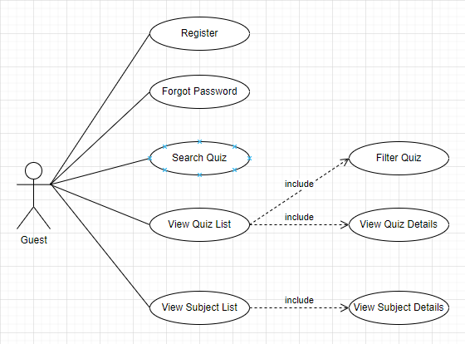

- Student  
  
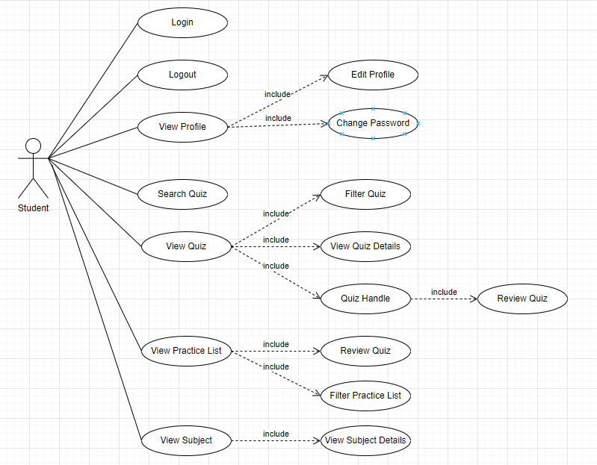  
  
- Expert  
  
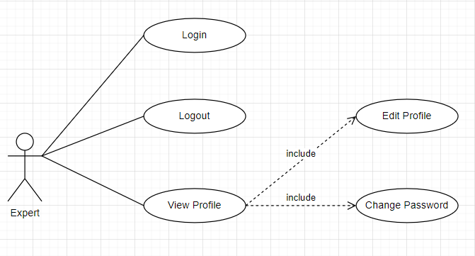  
  
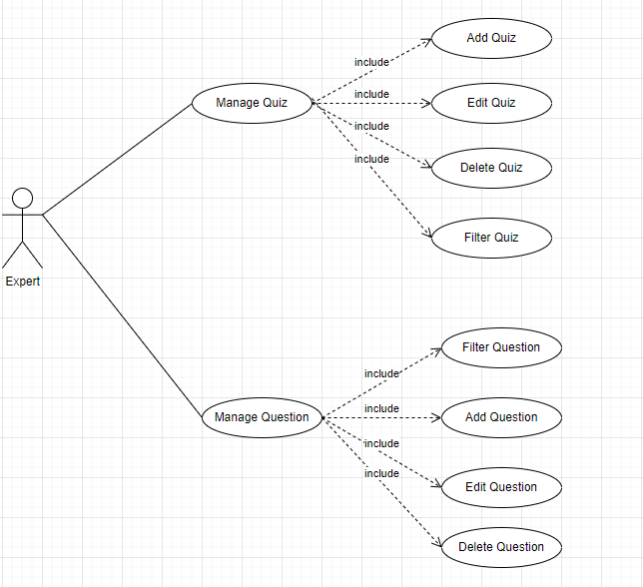  
- Admin  
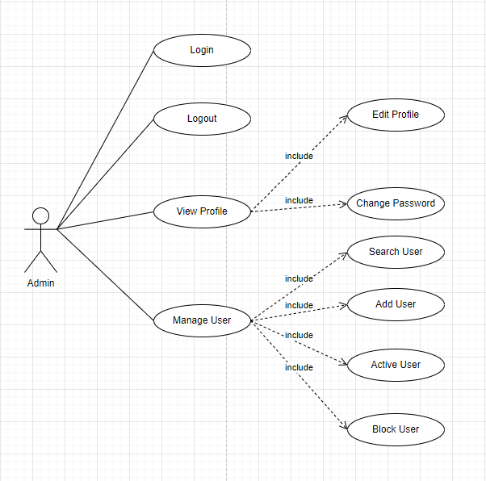

# 

# II. Functional Requirements

## 1. Feature Common

### **a. Login**

| **UI Element: Login** | | |
| --- | --- | --- |
| **UI Element Description** | | |
| ID | 1 | |
| Description | Login screen to user log in to system | |
| **UI Element Displays** | | |
| **Precondition** | **Display** | |
| Always | The login screen displayed includes:  - Return button   - A input: email type  - A input: password type, user-entered passwords will show * instead of clear characters.  - Login button: confirm data entered from input email and password.  - Link Forgot Password: go to Forgot Password Page  - Link Register: go to Register Page | |
| User enters email that does not exist in the system | The screen shows the message “Email doesn’t exist !” | |
| User enters the email that exists in the system but the password is wrong | The screen shows the message “Invalid Password !” | |
| **UI Element Behaviours** | | |
| **Precondition** | **Action** | **Respond** |
| User is not logged in | User clicks on return icon | System will redirect to Home page |
| User is not logged in | User clicks on forgot password link | System will redirect to Forgot Password page |
| User is not logged in | User clicks on register link | System will redirect to Register page |
| User is not logged in | User enters correct email and password and clicks on login button | System will redirect to Home page |
| User is not logged in | User enters correct email and password and clicks on login button but the account has not been activated | System will redirect to Verify page |
| User is not logged in | Input Login URL page in browser | System will redirect to Home page |
| User is logged in | Input Login URL page in browser | System will redirect to Home page |

| **Use Case ID** | UC-1 |
| --- | --- |
| **Name** | Login |
| **Actor** | Student, Expert, Admin |
| **Description** | The function allows a user to be able to login in the system when he/she have registered. |
| **Precondition** | The actor has an email that was used to register an account in the system. |
| **Trigger** | Click Login on the header of Home Page |
| **Post-Condition** | The actor is logged in to the system successfully. |
| **Frequency of Use** | Regularly |
| **Normal Flow:** | 1 Actor: Click the Login button on the header of the Home Page..  2 System: Displays Login page. 3 Actor: Login by entering the email that exists in the system and the correct password and clicking the login button.  4 System: Displays HomePage. |
| **Exception Flow:** | EF-1: At step 3 of NF 1 Actor: Enter an email that does not exist in the system, password, and click on the login button 2. System: Displays the message “Email doesn’t exist !”  EF-2: At step 3 of NF 1 Actor: Enter an email that exists in the system but the password is incorrect and click on the login button 2. System: Displays the message “Invalid Password !”  EF-3: At step 3 of NF 1 Actor: Enters the email that exists in the system and the correct password and clicks on the login button but the account has not been activated. 2. System: Redirect to Verify Page |

### **b. Register**

| **UI Element: Register** | | |
| --- | --- | --- |
| **UI Element Description** | | |
| ID | 2 | |
| Description | Register screen for new account registration users | |
| **UI Element Displays** | | |
| **Precondition** | **Display** | |
| Always | The register screen displayed includes:  - Return button   - A input: text type  - A input: email type  - A input: password type, user-entered passwords will show * instead of clear characters.  - A input: password type,user-entered passwords will show * instead of clear characters.  - 2 radio buttons to choose gender  - A input: date type, can select the date without manually entering it by clicking on the calendar icon on the right.  - Register button: confirm data entered from input username, email, password, confirm password, gender, dob.  - Link Login: go to Login Page | |
| User enters name already used | The screen will show the message “This username is already being used !” | |
| User enters email already used | The screen will show the message “This email address is already being used !” | |
| User entered confirm password does not match password | The screen will show the message“Password and Confirm Password must match!” | |
| **UI Element Behaviors** | | |
| **Precondition** | **Action** | **Respond** |
| User is not logged in | User clicks on return icon | System will redirect to Home page |
| User is not logged in | User clicks on login link | System will redirect to Login page |
| User is not logged in | User enters all fields without the same name, email already exists in the system, password and confirm password match, select gender and enter dob and click register button. | System will redirect to Verify page |

| **Use Case ID** | UC-2 |
| --- | --- |
| **Name** | Register |
| **Actor** | Guest |
| **Description** | This function allows guest users to register for an account. |
| **Precondition** | - The actor doesn’t have an account.  - The actor has an email not registered yet. |
| **Trigger** | Click Register on the header of Home Page |
| **Post-Condition** | This account will be saved for next time login. |
| **Frequency of Use** | Sometimes |
| **Normal Flow:** | 1 Actor: Click the Register button.  2 System: Displays the Register Page. 3 Actor: Input username and email is not used yet, password and confirm password match, choose gender and dob. Click on the Register button.  4 System: Displays Verify Page also sends a code to the email that you just used to register.  5 Actor: Input code that the system has sent to the email.  6 System: Displays Login Page. |
| **Exception Flow:** | EF-1: At step 3 of NF 1 Actor: Enter the username that already exists in the system. 2. System: Displays the message “This username is already being used !”  EF-2: At step 3 of NF 1 Actor: Enter the email that already exists in the system. 2. System: Displays the message “This email is already being used !”  EF-3: At step 3 of NF 1 Actor: Enter password and confirm password does not match.  2. System: Displays the message “Password and Confirm Password must match !” |

### C. Reset Password

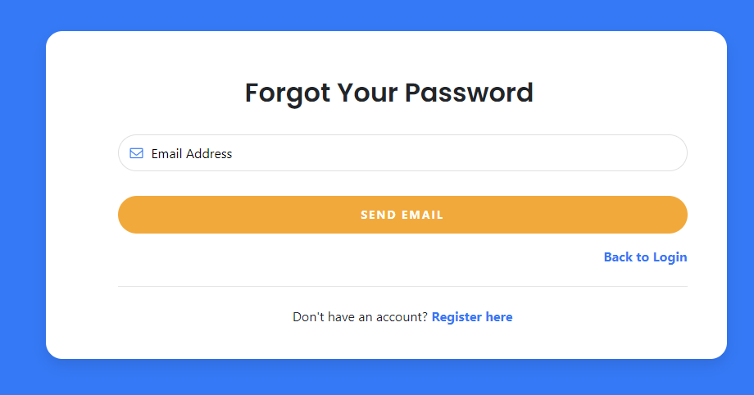

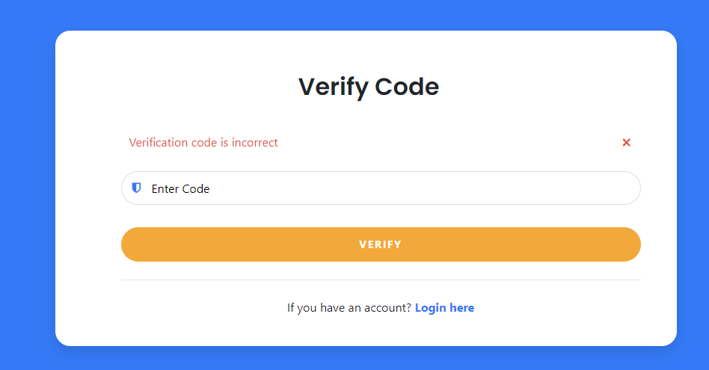

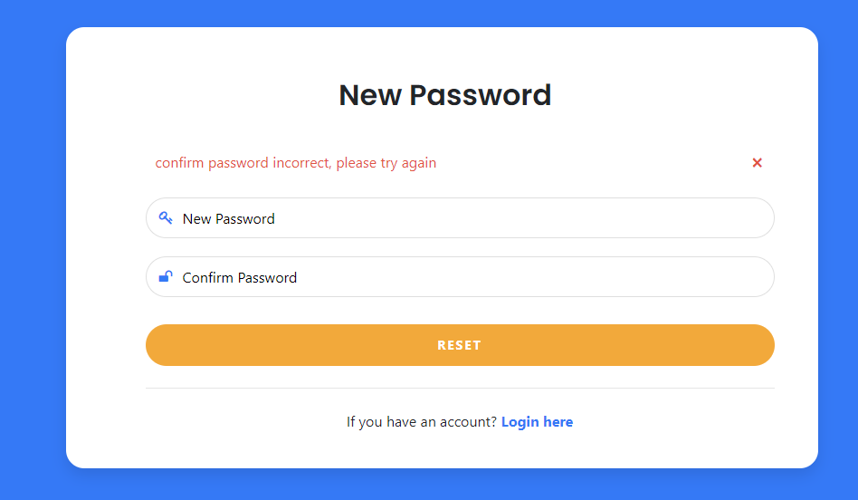

| **UI Element: Reset Password page** | | |
| --- | --- | --- |
| **UI Element Description** | | |
| ID | 3 | |
| Description | Forgot password screen for registered users to get code to get password | |
| **UI Element Displays** | | |
| **Precondition** | **Display** | |
| User entered the wrong email | The screen will show alert “Email does not exist!” | |
| User enters email field, email already exists in the system | System will redirect to VerifyCode Page | |
| User click link Back to Login | System will redirect to login page | |
| User entered the wrong code | The screen will show alert “Verification code is incorrect!” | |
| User enters code field, correct password | System will redirect to GetPassword Page | |
| User click link register | System will redirect to Register Page | |
| User entered the wrong Confirm Password | The screen will show alert “Confirm Password is incorrect!” | |
| User enters password field and confirm password, confirm password is correct | System will redirect to login Page | |
| **UI Element Behaviors** | | |
| **Precondition** | **Action** | **Respond** |
| User input email | Input Register URL page in browser | System will redirect to Forgot Password page |
| User not input email | Input Register URL page in browser | System will redirect to Home page |

| **Use Case ID** | UC-3 |
| --- | --- |
| **Name** | Forgot Password |
| **Actor** | Student, Expert, Admin |
| **Description** | The function allows users to retrieve the password that the account has registered |
| **Precondition** | The actor has a registered email |
| **Trigger** | Click Forgot Password on the Login Page |
| **Post-Condition** | The actor is reset password successful. |
| **Priority** | Medium |
| **Frequency of Use** | Regularly |
| **Normal flow:** | 1 Actor: Open login page of the Quiz Practice website.  2 System: displays login Page. 3 Actor: Click forgot password button..  4 System: displays forgot password page. 5 Actor: Forgot by input Email  6 System: if email does not exist , still displays forgot password page.  7 System: if email exist , displays verify code page.  8 Actor: Enter Code input  9 System: if The code entered is not correct , still displays verify code page.  10 System: if The code entered is correct , displays get Password page.  11 Actor: Enter new password and confirm password input  12 System: if confirm password is not correct , still displays get password page.  13 System: if confirm password is correct , displays login page. |
|  |  |

### **E. User Profile**

| **UI Element: User Profile page** | | |
| --- | --- | --- |
| **UI Element Description** | | |
| ID | 4 | |
| Description | This function displays some information of users such as name, gender, DOB, avatar and allows users to edit information when they want. | |
| **UI Element Displays** | | |
| **Precondition** | **Display** | |
| Always | Users screen will be displayed with:   * Username: * Gender: * DOB: * Avatar: | |
| **UI Element Behaviors** | | |
| **Precondition** | **Action** | **Respond** |
| Users are logged in | Users select “Profile” in the Username button on the navbar | System redirects to the User Profile page |
| Always | Student input all fields and click on “Save” button | New information of student will be update to the database |

| **Use Case ID** | UC-4 |
| --- | --- |
| **Name** | User Profile |
| **Actor** | Student, Expert, Admin |
| **Description** | This function allows the user to change his/her password by inputting his current password as well as new password (twice) |
| **Precondition** | Users logged in successfully |
| **Trigger** | Click on Username button and choose “Profile” |
| **Post-Condition** | Database will be updated |
| **Normal Flow** | 1, Actor: Login to the system  2, System: Displays Homepage  3, Actor: Click on “Profile” in the Username button on the navbar  4, System: Displays the Profile page.  5, Actor: Update information and click on “Save” button  6, System: Save successfully and update to the database |
| **Exceptions** | N/A |

### **F. Change Password**

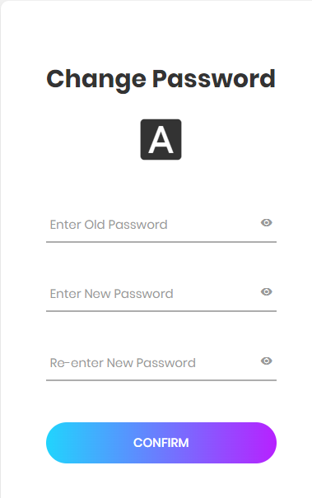

| **UI Element: Change Password page** | | |  |
| --- | --- | --- | --- |
| **UI Element Description** | | |  |
| ID | 5 | |  |
| Description | This function allows users to change his/her password by inputtting old new password, new password, re-enter password fields | |  |
| **UI Element Displays** | | |  |
| **Precondition** | **Display** | |  |
| Always | * Change Password screen will be display with: * Old password field:      * New Password field:      * Re-enter password field:      * Confirm button: | |  |
| **UI Element Behaviors** | | | |
| **Precondition** | **Action** | | **Response** |
| Users are logged in | Click on “Change Password” button | | System redirect to the Change Password page |
| Always | Click on “Old Password” field | | System allows users to input text into Old Password field |
| Always | Click on “New Password” field | | System allows users to input text into New Password field |
| Always | Click on “Re-enter Password” field | | System allows users to input text into Re-enter Password field |
| Always | Users enter all fields with correct format and click on “Submit” button | | System shows message “Update successfully” and update to the database |

| **Use Case ID** | UC-5 |
| --- | --- |
| **Name** | Change Password |
| **Actor** | Student, Expert, Admin |
| **Description** | This function allows the user to change his/her password by inputting his current password as well as new password (twice) |
| **Precondition** | Users logged in successfully |
| **Trigger** | Click on Username button and choose “Change Password” |
| **Post-Condition** | Database will be updated |
| **Normal Flow** | 1, Actor: Login to the system  2, System: Displays Homepage  3, Actor: Click on “Change Password” in the Username button on the navbar  4, System: Displays the Change Password page.  5, Actor: Enter all fields with correct format and click on “Confirm” button”  6, System: Update successfully |
| **Exceptions** | 1, When users enter the wrong old password, the screen will show the message “Old password is incorrect!”  2, When users enter new password that is duplicated with the old one, the screen will show the message “New password cannot be duplicated !”  3, When users enter re-enter password is different from the new one, the screen will show the message “Repassword does not match !” |

## 

## 2. Feature Public

#### a. Home ( Landing page )

| **UI Element: Home page** | | |
| --- | --- | --- |
| **UI Element Description** | | |
| ID | 6 | |
| Description | This screen shows the home page of the website. | |
| **UI Element Displays** | | |
| **Precondition** | **Display** | |
| Alway | Screen show Home page and 4 latest created courses  Button search and textbox search  Button home  Button quiz  Button subject  Button about  Button view | |
| Users not logged in | Screen show button login and register | |
| Users is logged in | Screen show button logout and name user and Button Profile | |
| **UI Element Behaviors** | | |
| **Precondition** | **Action** | **Respond** |
| Alway | User click button subject | System will redirect to Subject List |
| Alway | User click button Quiz | System will redirect to Quiz List |
| Alway | User click button view | System will redirect to Quiz Detail |
| Alway | User input string to text search and click button search | System will redirect to Quiz List with condition name quiz contain text user input |
| Users is not logged in | Input manage URL in browser | System will send back an error page and redirect back to home page |
| Users is not logged in | User click button login | System will redirect to Login page |
| Users is not logged in | User click button register | System will redirect to Register page |
| Users is logged in | User click button Profile | System will redirect to Profile page |
| Users is logged in | User click button log out | System will redirect to home page have button login and register |

| **Use Case ID** | UC-6 |
| --- | --- |
| **Actor** | All everyone |
| **Description** | Home's page of the website, introducing the website and showing the 4 most recently created quiz, user can login, register, logout |
| **Precondition** | **None** |
| **Trigger** | The homepage of the website, opened when accessing the web, or clicking the home button on the header bar while on another page of the web |
| **Post-Condition** | . |
| **Normal Flow** |  |
| **Exceptions** | None |
| **Priority** | Height |
| **Frequency of Use** | Height |
| **Business Rules** | Use in the computer/phone. |
| **Other Information** | N/A |
| **Assumptions** | N/A |

#### b, Subject List

| **UI Element: Subject List** | | |
| --- | --- | --- |
| **UI Element Description** | | |
| ID | 7 | |
| Description | This function displays list of subjects with pagination for users to select to view detail | |
| **UI Element Displays** | | |
| **Precondition** | **Display** | |
| Always | Subject List screen will be displayed with:   * List of subjects:      * Pagination      * View button on subjects: | |
| **UI Element Behaviors** | | |
| **Precondition** | **Action** | **Respond** |
| Users are logged in | Users click on “Subject” button on the navbar | System redirects to the list of subjects with pagination |
| Always | Users click on “View” button on any subjects | System redirects to the details of subjects |
| Always | Users click on “Previous” button | System shows the list of subjects of the previous page |
| Always | Users click on “Next” button | System shows the list of subjects of the next page |

| **Use Case ID** | 7 |
| --- | --- |
| **Name** | Subject List |
| **Actor** | Student, Expert, Admin |
| **Description** | This function displays list of subjects with pagination for users to select to view detail |
| **Precondition** | Users logged in successfully |
| **Trigger** | Users click on “Subject” button on the navbar |
| **Post-Condition** | System redirects to Subject Detail page |
| **Normal Flow** | 1, Actor: Login to the system  2, System: Displays Homepage  3, Actor: Click on “Subject” button on the navbar  4, System: Displays the list of subjects with pagination.  5, Actor: Click on “View” button on any subjects  6, System: Redirects to the details of the subjects |
| **Exceptions** | N/A |

#### c, Subject Detail

| **UI Element: Subject Detail** | | |
| --- | --- | --- |
| **UI Element Description** | | |
| ID | 8 | |
| Description | This function allows users view detail of selected subjects with information (image ,title, description) and a “View list quiz” button to redirect to list quiz of selected subjects | |
| **UI Element Displays** | | |
| **Precondition** | **Display** | |
| Always | Subject List page screen will be displayed with   * Image: * Title:      * Description      * View list quiz button | |
| **UI Element Behaviors** | | |
| **Precondition** | **Action** | **Respond** |
| Users click on “Subject” button on the navbar | Users click on “View” button on selected subjects | System shows the detail of subject |
| Always | Users click on “View List Quiz” button | System redirect to the List Quiz page |

| **Use Case ID** | 8 |
| --- | --- |
| **Name** | Subject Detail |
| **Actor** | Student, Expert, Admin |
| **Description** | This function allows users view detail of selected subjects with information (image ,title, description) and a “View list quiz” button to redirect to list quiz of selected subjects |
| **Precondition** | Users click on “View” button on selected subject |
| **Trigger** | * Users click on “Subject” button on the navbar * Users click on “View” button on selected subjects |
| **Post-Condition** | System redirect to the List Quiz page |
| **Normal Flow** | 1, Actor: Login to the system  2, System: Displays Homepage  3, Actor: Click on “Subject” button on the navbar  4, System: Displays the list of subjects with pagination.  5, Actor: Click on “View” button on any subjects  6, System: Redirects to the details of the subjects  7, Actor: Click on “View List Quiz” button  8, System: Redirect to the List Quiz page |
| **Exceptions** | N/A |

## 3. Feature Student

#### a.Practice List

#### 

| **UI Element: Practice List** | | |
| --- | --- | --- |
| **UI Element Description** | | |
| ID | 9 | |
| Name | Practice List | |
| Description | Practice List screen for the student to view all the results of the quiz he/she did. Besides, there is a combobox to be able to filter the quiz by subject. | |
| **UI Element Displays** | | |
| **Precondition** | **Display** | |
| User logged into the system as Student | * Header:  - Home button to go to Home page  - Home button to go to Quiz List page  - Subject button to go to Subject List page  - Search bar includes: input to enter, Search button to search quiz by quiz name  - Display username when logging into the system   - When click on the username, there will be 4 items displayed  * Body:  - 1 Combobox to filter quiz by subject   - 1 table to display the list of quiz done:  - The first row is blue separate from the other rows with columns quiz name, subject, answered, number correct answers, score, complete time, submit at, details. | |
| User has not taken any quiz | - Show message “You haven't taken any quiz yet.” | |
| Users filter quiz by subject but quiz in that subject they haven't taken | - Show message “You have not taken any quiz related to this subject.” | |
| **UI Element Behaviors** | | |
| **Precondition** | **Action** | **Respond** |
| User logged into the system is student | Click home button | System will redirect Home page |
| User logged into the system is student | Click quiz button | System will redirect Quiz List page |
| User logged into the system is student | Click subject button | System will redirect Subject List page |
| User logged into the system is student | Click details button | System will redirect Quiz Review page |
| User logged into the system is student | Click on their name, select the item profile | System will redirect User Profile page |
| User logged into the system is student | Click on their name, select the item change password | System will redirect Change Password page |

#### 

| **Use Case ID** | UC-9 |
| --- | --- |
| **Name** | View Practice List |
| **Actor** | Student |
| **Description** | This function allows students to view all the results of the quiz they have taken |
| **Precondition** | - User must log in to the system as Student |
| **Trigger** | - Users click on their name in the top right corner of the home page header and select 'My Practice List'. |
| **Post-Condition** | .N/A |
| **Normal Flow** | NF-1 1 Actor: Log in to the system.  2 System: Displays the Home Page. 3 Actor: Click on their name in the right corner of the home page header and select My Practice List.  4 System: Displays Practice List Page. 5. Actor: Click the details link in the detail column of the quiz they want to review the process they took that quiz.  6. System: Displays Quiz Review Page. 7. Actor: Review all the answered questions and click the finish review button 8. System: Displays Home Page. |
| **Exception Flow** | EF-1: At step 3 of NF-1 1 Actor: Student has not taken any quiz. 2. System: Displays message “You haven't taken any quiz yet.”. |

#### 

| **Use Case ID** | UC-10 |
| --- | --- |
| **Name** | Filter Practice List |
| **Actor** | Student |
| **Description** | This function allows students to filter all the results of the quiz they have taken by subject |
| **Precondition** | - User must log in to the system as Student |
| **Trigger** | - Users click on combo box on the practice list page. |
| **Post-Condition** | .N/A |
| **Normal Flow** | NF-1 1 Actor: Log in to the system.  2 System: Displays the Home Page. 3 Actor: Click on their name in the right corner of the home page header and select My Practice List.  4 System: Displays Practice List Page.  5 Actor: Filter quiz by the subject that he/she has chosen.  6 System: Display quizzes that the student has done related to that subject. 7. Actor: Click the details link in the detail column of the quiz they want to review the process they took that quiz.  8. System: Displays Quiz Review Page. 9. Actor: Review all the answered questions and click the finish review button 10. System: Displays Home Page. |
| **Exception Flow** | EF-1: At step 5 of NF-1 1 Actor: Student has not taken any quiz related to that subject. 2. System: Displays message “You have not taken any quiz related to this subject.”. |

#### 

#### b.Quiz Handle

#### 

#### 

| **UI Element: QuizHandle** | | |
| --- | --- | --- |
| **UI Element Description** | | |
| ID | 10 | |
| Description | Page where users can practice and submit quiz | |
| **UI Element Displays** | | |
| **Precondition** | **Display** | |
| The user is logged in and has the role of student | - Back button  - Progress review button  - button Previous Question  - button Next Question  - button Submit Exam  - Time left to take quiz  - The order number of the question in progress  - Total number of questions  - Question and options for the question in progress | |
| User is student, clicks on Review Progress | - Button Back  - Button Score Exam  - Button show question number | |
| User is student, has not done any questions and clicks Submit Exam | - Button Back  - Button Exit Exam  - Message "  Exit Exam ?  You have not answered any questions. By clicking on the [Exit Exam] button below you will complete your current exam and be returned to the dashboard” | |
| User is student, has not completed all the questions and clicks Submit Exam | - Button Back  - Button Exit Exam  - Message "  Exit Exam ?  Number of questions done of total number of questions  By clicking on the [Score Exam] button below, you will complete your current exam and receive your score. You will not be able to change any answers after this point " | |
| User is student, complete all questions and click Submit Exam | - Button Back  - Button Exit Exam  - Message "  Exit Exam ?  "By clicking on the [Score Exam] button below, you will complete your current exam and receive your score. You will not be able to change any answers after this point” | |
| **UI Element Behaviors** | | |
| **Precondition** | **Action** | **Respond** |
| The user is logged in and has the role of student | Click button Review Progress | System shows Pop-up Review progress |
| The user is logged in and has the role of student | Click button Previous Question | System shows previous question |
| The user is logged in and has the role of student | Click button Next Question | System shows next question |
| The user is logged in and has the role of student | Click button Submit | System shows Pop-up Exit Exam |
| User is student, click Submit Exam | Click button Back | System disables all pop-ups |
| User is student, click Submit Exam | Click button Exit Exam | System will redirect Quiz Review |
| User is student, click Review Progress | Click button Back | System disables all pop-ups |
| User is student, click Review Progress | Click button show question number | The system displays the question with the selected sequence number |
| User is student, click Review Progress | Click button Exit Exam | System will redirect Quiz Review |

| **Use Case ID** | UC-12 |
| --- | --- |
| **Actor** | Student |
| **Description** | The system displays questions and answers for user to choose, user can choose 1 answer for a question and submit |
| **Precondition** | User must log in to the system with the role of student |
| **Trigger** | User click button Practice |
| **Post-Condition** |  |
| **Normal Flow** | 1 Actor: Open Quiz Practice website.  2 System: Displays Home Page.  NF-1  3 Actor: Click the quiz button in the header of the home page.  4 System: Displays the Quiz List Page. 5 Actor: User clicks on the practice button of any quiz.  6 System: Displays Quiz Handle Page.    NF-2  3 Actor: Click the quiz button in the header of the home page.  4 System: Displays the Quiz List Page. 5 Actor: Click button Detail of the any quiz  6 System: Displays the Quiz Detail  7 Actor: User clicks on the practice button of the quiz.  8 System: Displays Quiz Handle Page.  NF-3  3 Actor: User clicks on the practice button of quiz in the Home page  4 System: Displays Quiz Handle Page. |
| **Exceptions** | None |
| **Priority** | Height |
| **Frequency of Use** | Height |
| **Business Rules** | Use in the computer/phone. |
| **Other Information** | N/A |
| **Assumptions** | N/A |

#### c.Quiz Review

| **UI Element: Quiz Review** | | |
| --- | --- | --- |
| **UI Element Description** | | |
| ID | 12 | |
| Description | Quiz Review screen for users to review the progress of the quiz they have taken | |
| **UI Element Displays** | | |
| **Precondition** | **Display** | |
| Always | The quiz review screen displayed includes:  - Back button: return Home Page.  - Score: displays the number of points achieved by the user (in %).  - Complete Time: displays the time it took the user to complete the quiz.  - Submit: show time when user submitted quiz (in the format of day/month/year hour:minute: second).  - The position of the question being viewed / the total number of questions in the quiz  - The first row shows the location of the question the user is viewing and the content of that question  - Below are the options, the wrong options will have an x next to them, the correct option will show a checkmark.  - For options selected by the user, a picture of 'your answer' will be displayed to the left of that option.    - Review Result button: a window pop-ups including 3 inputs (image type), displays all questions, for questions the user does not answer, the background will be white, the questions the user answered, the background will be black.  - Explanation button: a window pop-ups showing the explanation of the question.  - Previous button: view previous question.  - Next button: view next question. | |
| User view first question | - Previous button will not display. | |
| User view last question | - Next button will not display. - Finish Review button will display. | |
| Questions with pictures | - Image shows the right half, the question and option show the left half | |
| User view question that they unanswered | - Show message “You did not answer this option” | |
| **UI Element Behaviors** | | |
| **Precondition** | **Action** | **Respond** |
| Users is logged in | User clicks on back button | System will redirect to Home page |
| Users is logged in | User clicks on finish review button | System will redirect to Home page |
| Users is logged in | User clicks on previous button | System displays the previous question |
| Users is logged in | User clicks on next button | System displays the next question |
| Users is logged in | User clicks on explanation button | A window pops up with an explanation for that question |
| Users is logged in | User clicks on all question | A window pops up show all questions |
| Users is logged in | User clicks on answered | A window pops up show questions that the user has answered |
| Users is logged in | User clicks on unanswered | A window pops up show questions that the user did not answer |
| Users is logged in | User clicks on finish review button | System will redirect to Home page |

#### 

| **Use Case ID** | UC-13 |
| --- | --- |
| **Name** | Review Quiz |
| **Actor** | Student |
| **Description** | The function allows the user to review the quiz that he/she did. |
| **Precondition** | - User must log in to the system  - User answers the questions in the quiz, then they submit and they want to review their progress on the quiz |
| **Trigger** | - User clicks the Submit Exam button on the Quiz Handle page.  - User clicks the Detail button on the Practice List page |
| **Post-Condition** | .N/A |
| **Normal Flow** | NF-1 1 Actor: Click the quiz button in the header of the home page.  2 System: Displays the Quiz List Page. 3 Actor: Click on the practice button of the quiz that they want to take.  4 System: Displays Quiz Handle Page.  5 Actor: Answer all questions belong that quiz and click the finish button  6 System: Displays Quiz Review Page. 7. Actor: Review all the answered questions and click the finish review button 8. System: Displays Home Page.  NF-2  1 Actor: Click their name in the header of the home page and choose the item on my practice list.  2 System: Displays Practice List Page. 3. Actor: Click on the detail button in any row 4. System: Displays Quiz Review Page 5. Actor: Review all the answered questions and click the finish review button 6. System: Displays Home Page. |
| **Exception Flow** | EF-1: At step 7 of NF-1 and step 5 of NF-2 1 Actor: View questions they don't answer 2.System: Displays message “You did not answer this option”. |

#### d.View Quiz List

**QuizList:**  
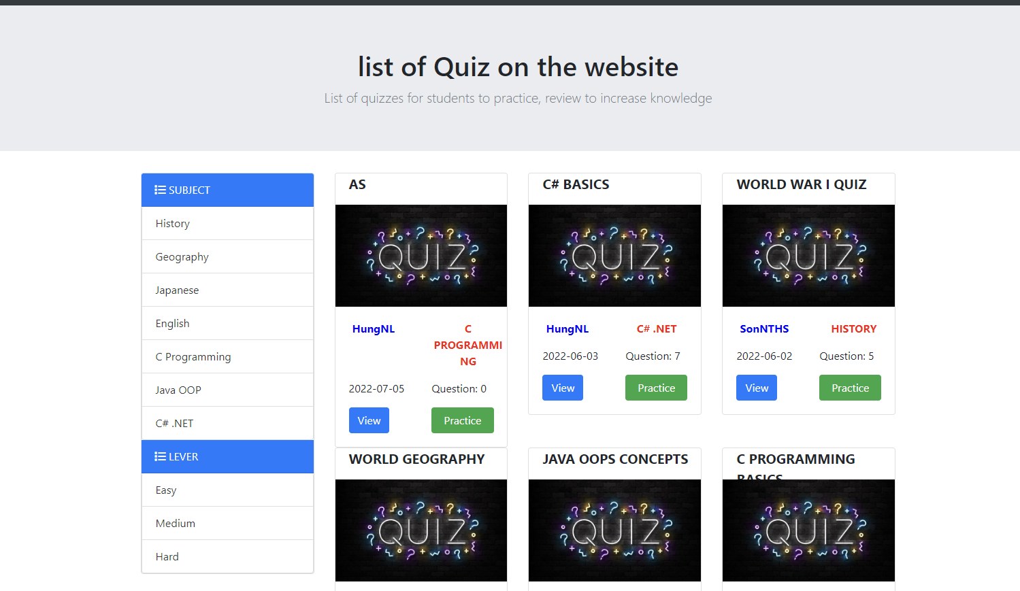

**FilterQuizBySubject:**  
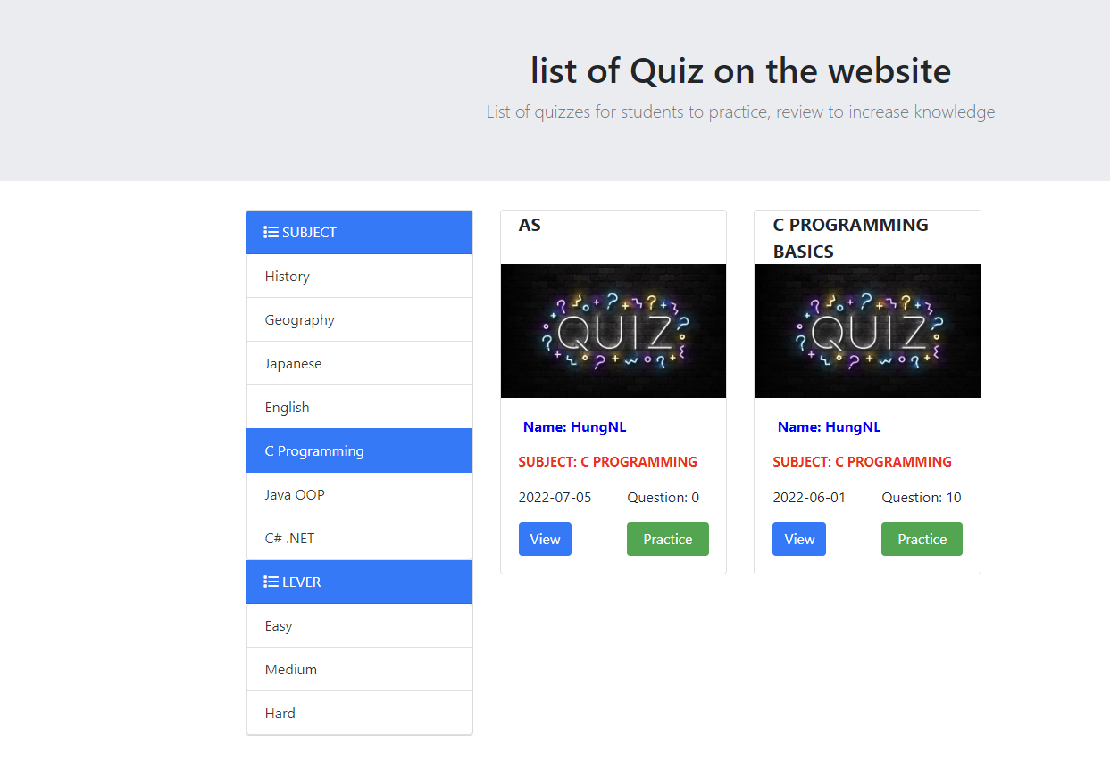

**FilterQuizByQuizLevel:**

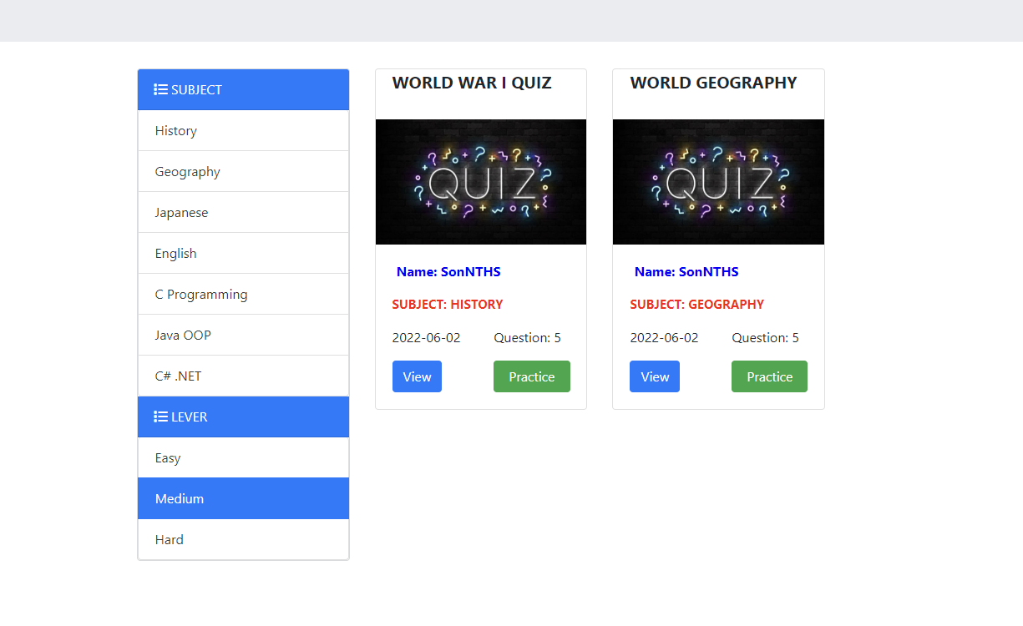

#### 

| **UI Element: QuizList** | | |
| --- | --- | --- |
| **UI Element Description** | | |
| ID | 13 | |
| Description | View Quiz List screen for the user to see all the quizzes available in the web | |
| **UI Element Displays** | | |
| **Precondition** | **Display** | |
| Always | Page display quiz list ( including image quiz, name quiz, subject name , expert name , date Created,number Question) | |
| User click on any one subject | The screen will show “All quizzes filtered by that subject!” | |
| User click on any one QuizLevel | The screen will show “All quizzes filtered by that Quiz level !” | |
| **UI Element Behaviors** | | |
| **Precondition** | **Action** | **Respond** |
| Users is not logged in | User clicks on practice button | System will redirect to login page |
| Users is logged in | User clicks on practice button | System will redirect to quizHandle page |
| Users is (not) logged in | User clicks on view button | System will redirect to quiz detail page |
| Users is (not) logged in | User clicks on Expert name button | System will redirect to expert detail page |

#### 

| **Use Case ID** | UC-14 |
| --- | --- |
| **Name** | View Quiz List |
| **Actor** | Admin, Expert,Student |
| **Description** | This function allows the user to view all the quizzes available in the web and that can filter by Subject , and quizLevel |
| **Precondition** | - The user wants to see all the quizzes available in the web  - the user clicks on the quiz in the header of the home page |
| **Trigger** | - User clicks the quiz button on the Quiz homepage. |
| **Post-Condition** | .N/A |
| **Normal Flow** | 1 .Actor: Click the quiz button in the header of the home page.  2. System: Displays the Quiz List Page.  3.. Actor: Click on any one subject  4. System: Displays list quiz is filtered by that subject  5. Actor: Click on any one quizlevel  6. System: Displays list quiz is filtered by that quiz level |

#### 

#### e.View Quiz Details

| **UI Element: QuizDetails** | | |
| --- | --- | --- |
| **UI Element Description** | | |
| ID | 14 | |
| Description | View Quiz Details screen for users to see the details of the quiz | |
| **UI Element Displays** | | |
| **Precondition** | **Display** | |
| Always | The page displays the details of the question (including the topic name, the image of the question name, the expert's name, the date of creation, the number of the Question, the time of the test , quiz level) | |
| **UI Element Behaviors** | | |
| **Precondition** | **Action** | **Respond** |
| Users is not logged in | User clicks on practice button | System will redirect to login page |
| Users is logged in | User clicks on practice button | System will redirect to quizHandle page |
| Users is (not) logged in | User clicks on back button | System will redirect to quiz quiz list page |

| **Use Case ID** | UC-15 |
| --- | --- |
| **Name** | View Quiz Details |
| **Actor** | Admin, Expert,Student |
| **Description** | This function allows the user to view detailed information in that quiz |
| **Precondition** | - The user wants to see all information in the quiz  - the user clicks on the view in the header of the quizlist page |
| **Trigger** | - User clicks the view button on the Quiz homepage. |
| **Post-Condition** | .N/A |
| **Normal Flow** | 1 .Actor: Click the quiz button in the header of the home page.  2. System: Displays the Quiz List Page.  3.. Actor: Click the view button in any quiz  4. System: Displays quiz detail page |

#### 

## 

## 

## 

## 

## 

## 

## 

## 4. Feature Expert

### a. Question Management

#### View Question List

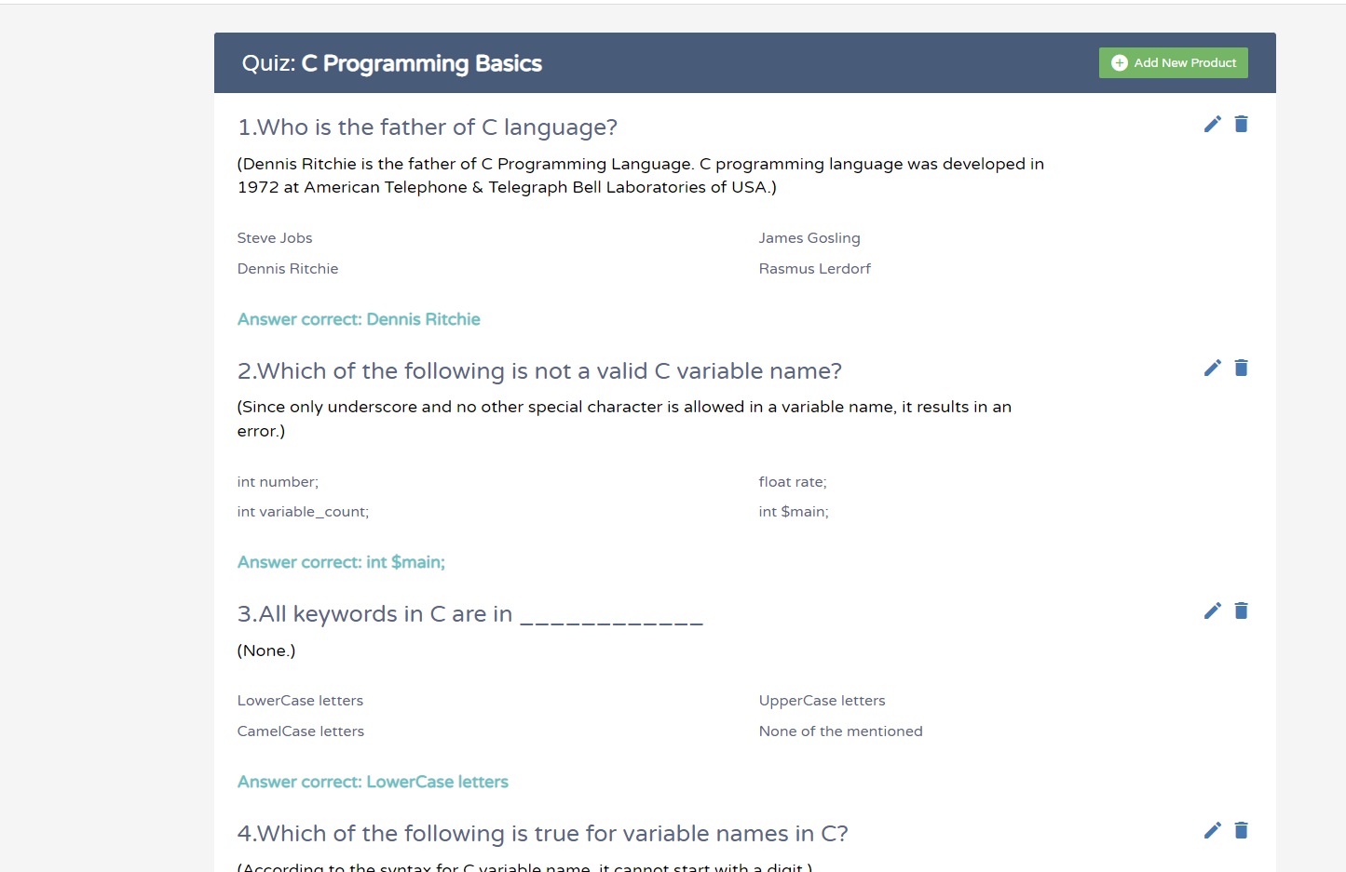

| **UI Element: Views Question List** | | |
| --- | --- | --- |
| **UI Element Description** | | |
| ID | 15 | |
| Description | This function allows the Expert to view all the questions he/she has created in the quiz | |
| **UI Element Displays** | | |
| **Precondition** | **Display** | |
| Always | Page display question list  Include question name:    Opton name:  Explanation name:    Image (if have):    Correct answer:    Button add new question:    Button edit for question:    button Delete for question:    button back: | |
| **UI Element Behaviors** | | |
| **Precondition** | **Action** | **Respond** |
| Expert is logged in | Expert clicks back button | System will redirect to QuizList page |
| Expert is logged in | Expert clicks cancel button on add question screen | System will redirect to Management question page |
| Expert is logged in | Expert clicks Add button on add question screen | System will redirect to Management question page |
| Expert is logged in | Expert clicks back button on Edit Question screen | System will redirect to Management question page |
| Expert is logged in | Expert clicks Edit button on Edit Question screen | System will redirect to Management question page |

#### 

| **Use Case ID** | UC-16 |
| --- | --- |
| **Name** | Views Question List |
| **Actor** | Expert |
| **Description** | This function allows the Expert to view all the questions he/she has created in the quiz |
| **Precondition** | -User must be an expert  -Expert created the questions |
| **Trigger** | - User clicks the question button on the QuizList HomePage. of Expert |
| **Post-Condition** | .Expert has logged into the system |
| **Normal Flow** | 1. Actor: Log in to the system.  2. System: Displays Home Page.  3. Actor: Click on the user's name in the top right corner of the home page header and select 'Manage'  4 System: Displays the Quiz List Page of Expert  5.. Actor: Click the Question button in the QuizList page  6. System: Displays Management Question page |

#### 

#### Add New Question

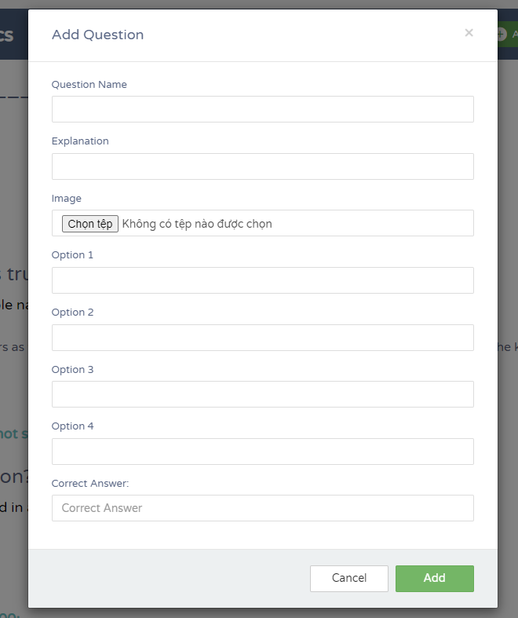

| **UI Element: Add New Question** | | |
| --- | --- | --- |
| **UI Element Description** | | |
| ID | 16 | |
| Description | This function allows the Expert to add new questions in the quiz | |
| **UI Element Displays** | | |
| **Precondition** | **Display** | |
| Always | Include question input:    Opton input:    Explanation input:    Correct input:    Image input:    Button add :    Button Cancel: | |
| **UI Element Behaviors** | | |
| **Precondition** | **Action** | **Respond** |
| Expert is logged in | Expert clicks Cancel button | System will redirect to QuizList page |
| Expert is logged in | Expert clicks Add button | System will redirect to QuizList page |

#### 

| **Use Case ID** | UC-17 |
| --- | --- |
| **Name** | Add New Question |
| **Actor** | Expert |
| **Description** | This function allows the Expert to add new questions to the Quiz |
| **Precondition** | -User must be an expert  -User want to add new question |
| **Trigger** | - User clicks Add new question button on the Management Question Page of Expert |
| **Post-Condition** | .Expert has logged into the system |
| **Normal Flow** | 1.Actor: Click on the user's name in the top right corner of the home page header and select 'Manage'  2. System: Displays the Quiz List Page of Expert  3. Actor: Click the Question button in the QuizList page  4. System: Displays Management Question page  5.Actor: Click the Add new Question button in the header of the Management Question page  6. System: Displays the Add Question screen  7. Actor: Enter Content Question,Options,Explanation,Correct answer and click add button  8.System : Display management quiz of Expert |
| **Exception Flow** | 1.Actor: Admin leave 1 in all fields blank  2. System:Display “Vui Lòng Điền Vào Trường Này”  3.Actor: Admin enter correct answer greater than 4  4.System: Display “ Giá trị phải nhỏ hơn hoặc bằng 4 “  5.Actor: Admin enter correct answer left than 1  6.System: Display “ Giá trị phải Lớn hơn hoặc bằng 1 “ |

#### 

#### Update Question

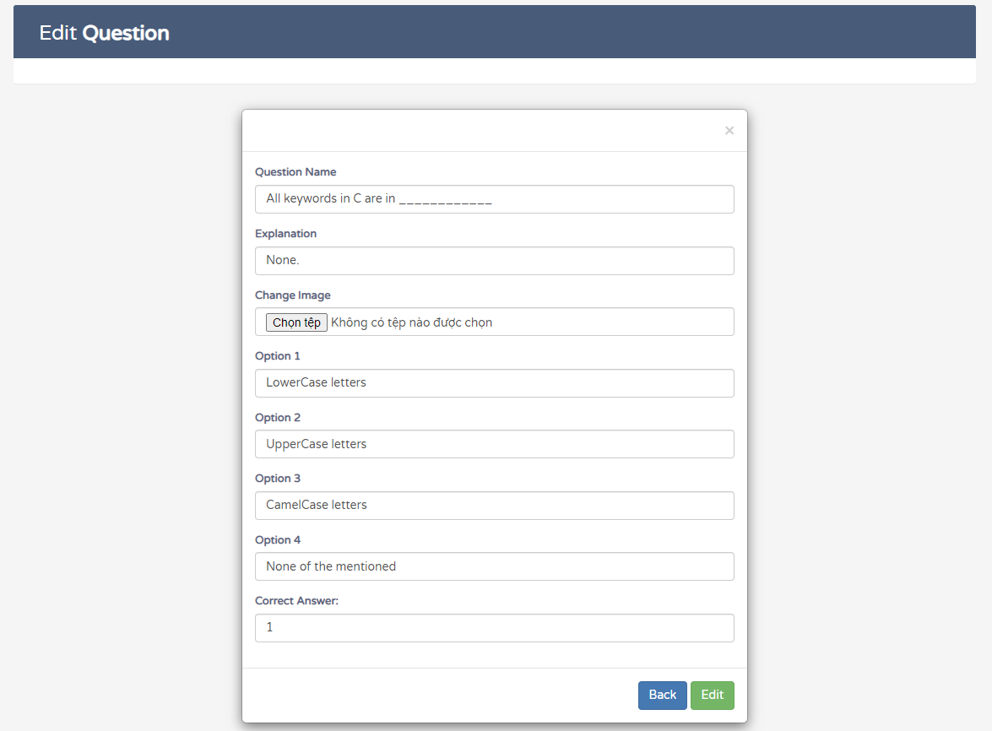

| **UI Element: Update Question** | | |
| --- | --- | --- |
| **UI Element Description** | | |
| ID | 17 | |
| Description | This function allows the Expert to update questions in the quiz | |
| **UI Element Displays** | | |
| **Precondition** | **Display** | |
| Always | Include question Name:    Opton Name:    Explanation Name:    Correct Name:    Image Name:    Button edit :    Button back: | |
| **UI Element Behaviors** | | |
| **Precondition** | **Action** | **Respond** |
| Expert is logged in | Expert clicks back button | System will redirect to QuizList page |
| Expert is logged in | Expert clicks Edit button | System will redirect to QuizList page |

#### 

| **Use Case ID** | UC-18 |
| --- | --- |
| **Name** | Update Question |
| **Actor** | Expert |
| **Description** | This function allows the Expert to Update questions to the Quiz |
| **Precondition** | -User must be an expert  -User want to Update question |
| **Trigger** | - User clicks Update question button on the Manager Question Page of Expert |
| **Post-Condition** | .Expert has logged into the system |
| **Normal Flow** | 1.Actor: Click on the user's name in the top right corner of the home page header and select 'Manage'  2. System: Displays the Quiz List Page of Expert  3. Actor: Click the Question button in the QuizList page  4. System: Displays Management Question page  5.Actor: Click the Update Question button in the header of the Management Question page  6. System: Displays the Update question screen  7. Actor: Enter Content Question,Options,Explanation,Correct answer Expert want to edit and click edit button  8.System : Display management quiz of Expert |
| **Exception Flow** | 1.Actor: Admin leave 1 in all fields blank  2. System:Display “Vui Lòng Điền Vào Trường Này”  3.Actor: Admin enter correct answer greater than 4  4.System: Display “ Giá trị phải nhỏ hơn hoặc bằng 4 “  5.Actor: Admin enter correct answer left than 1  6.System: Display “ Giá trị phải Lớn hơn hoặc bằng 1 “ |

#### Delete Question

| **Use Case ID** | UC-19 |
| --- | --- |
| **Name** | Delete Question |
| **Actor** | Expert |
| **Description** | This function allows the Expert to delete questions to the Quiz |
| **Precondition** | -User must be an expert  -User want to delete question |
| **Trigger** | - User clicks delete question button on the Manager Question of Expert |
| **Post-Condition** | .Expert has logged into the system |
| **Normal Flow** | 1.Actor: Click on the user's name in the top right corner of the home page header and select 'Manage'  2. System: Displays the Quiz List Page of Expert  3. Actor: Click the Question button in the QuizList page  4. System: Displays Management Question page  5.Actor: Click the Delete Question button in the header of the Management Question page  6.System : Display management quiz of Expert |

#### 

### b. Quiz Management

***a.View Quiz List***

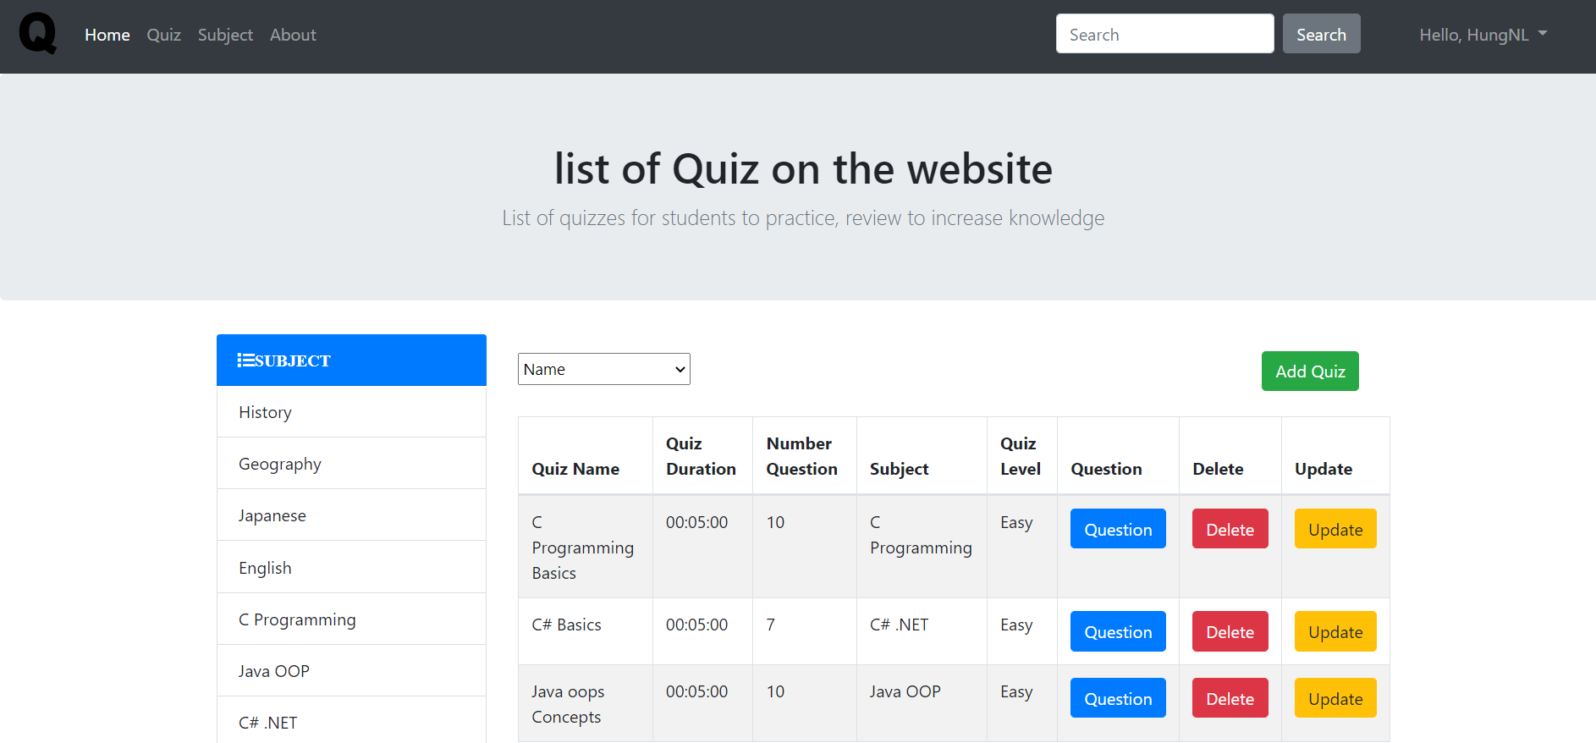

#### 

| **UI Element: Quiz Management** | | |
| --- | --- | --- |
| **UI Element Description** | | |
| ID | 18 | |
| Description | The page displays quizzes that expert users create and can add, edit and delete their Quiz, quiz information | |
| **UI Element Displays** | | |
| **Precondition** | **Display** | |
| The user is logged in and has the role of expert | * Button add quiz * Button Question * Button Delete * Button Update * Combobox option: Name, Quiz Duration, Number of Question * Buttons subject name * Button level * Information Quiz | |
| **UI Element Behaviors** | | |
| **Precondition** | **Action** | **Respond** |
| The user is expert, and click button Add quiz | Click button Add quiz | System will redirect Add quiz Page |
| The user is expert, and click button Update quiz | Click button Update quiz | System will redirect Update quiz Page |
| The user is expert, and click button Delete quiz | Click button Delete quiz | System will redirect list quiz Page without quiz deleted |
| The user is expert, and click choose subject | Click choose subject | The system shows quizzes belonging to the subject |
| The user is expert, and click choose level | Click choose level | The system shows quizzes whose level is equal to the selected level |
| The user is expert, and choose attribute to sort | Click choose attribute to sort | Click on properties to sort quiz |

| **Use Case ID** | UC- 20 |
| --- | --- |
| **Actor** | Expert |
| **Description** | This function allows the expert to see the information of the quiz that the expert owns, sort users by: name , quiz duration, number of question , filter courses by subject or level |
| **Precondition** | User must log in to the system with the role of expert |
| **Trigger** | User click button Manage |
| **Post-Condition** |  |
| **Normal Flow** | 1 Actor: Open Quiz Practice website.  2 System: Displays Home Page.  3 Actor: Click vào “Hello,tên”  4 System: Display dropdown  5 Actor: Click Button Manager  6 System: Display list quiz Page |

#### 

***b.Add New Quiz***

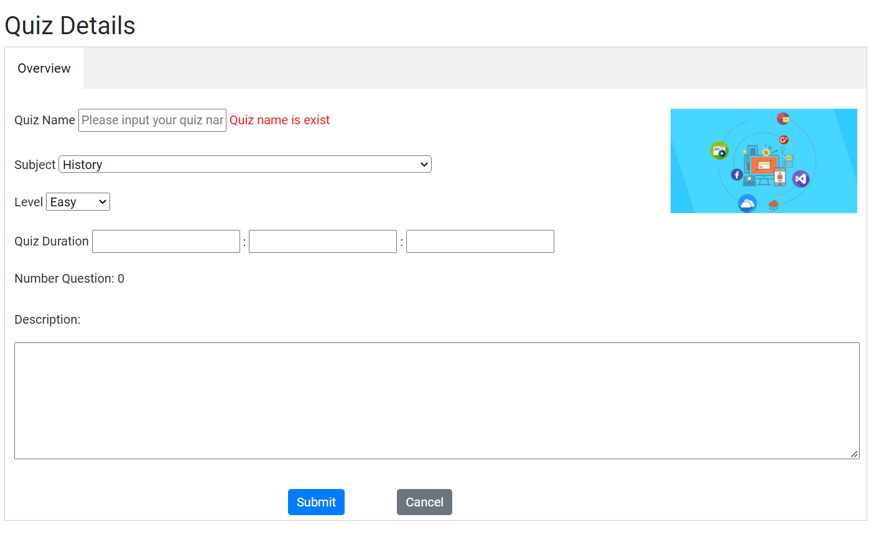

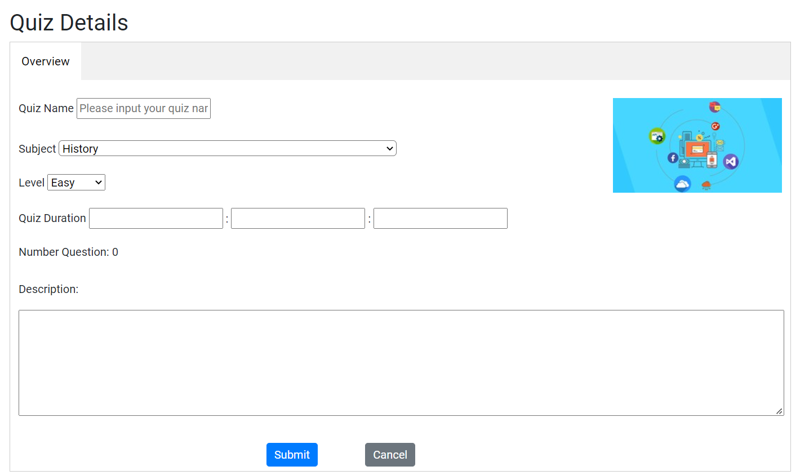

#### 

| **UI Element Description** | | |
| --- | --- | --- |
| ID | 19 | |
| Description | The page allows the Expert to enter the information of the quiz you want to create | |
| **UI Element Displays** | | |
| **Precondition** | **Display** | |
| The user is logged in and has the role of expert | * Input text to enter name quiz * Combobox to select subject * Combobox to select level * Input to enter hours minutes seconds * Input text to enter description quiz | |
| The user is logged in and has the role of expert and the name entered is the same as the existing quiz name | * Input text to enter name quiz * Combobox to select subject * Combobox to select level * Input to enter hours minutes seconds * Input text to enter description quiz * Message “Quiz name is exist “ | |
| **UI Element Behaviors** | | |
| **Precondition** | **Action** | **Respond** |
| The user is expert, and click button Cancel | Click button Cancel | System will redirect quiz list Page |
| The user is expert, and click button submit | Click button submit quiz | System will redirect quiz list Page |

| **Use Case ID** | UC- 21 |
| --- | --- |
| **Actor** | Expert |
| **Description** | This function allows the expert to information new quiz |
| **Precondition** | User must log in to the system with the role of expert |
| **Trigger** | User click button Add quiz |
| **Post-Condition** |  |
| **Normal Flow** | 1 Actor: Open Quiz Practice website.  2 System: Displays Home Page.  3 Actor: Click vào “Hello,tên”  4 System: Display dropdown  5 Actor: Click Button Manager  6 System: Display list quiz Page  7 Actor: Click button Add quiz  8 System: Display add quiz Page |
| **Exception** |  |

***c.Update New Quiz***

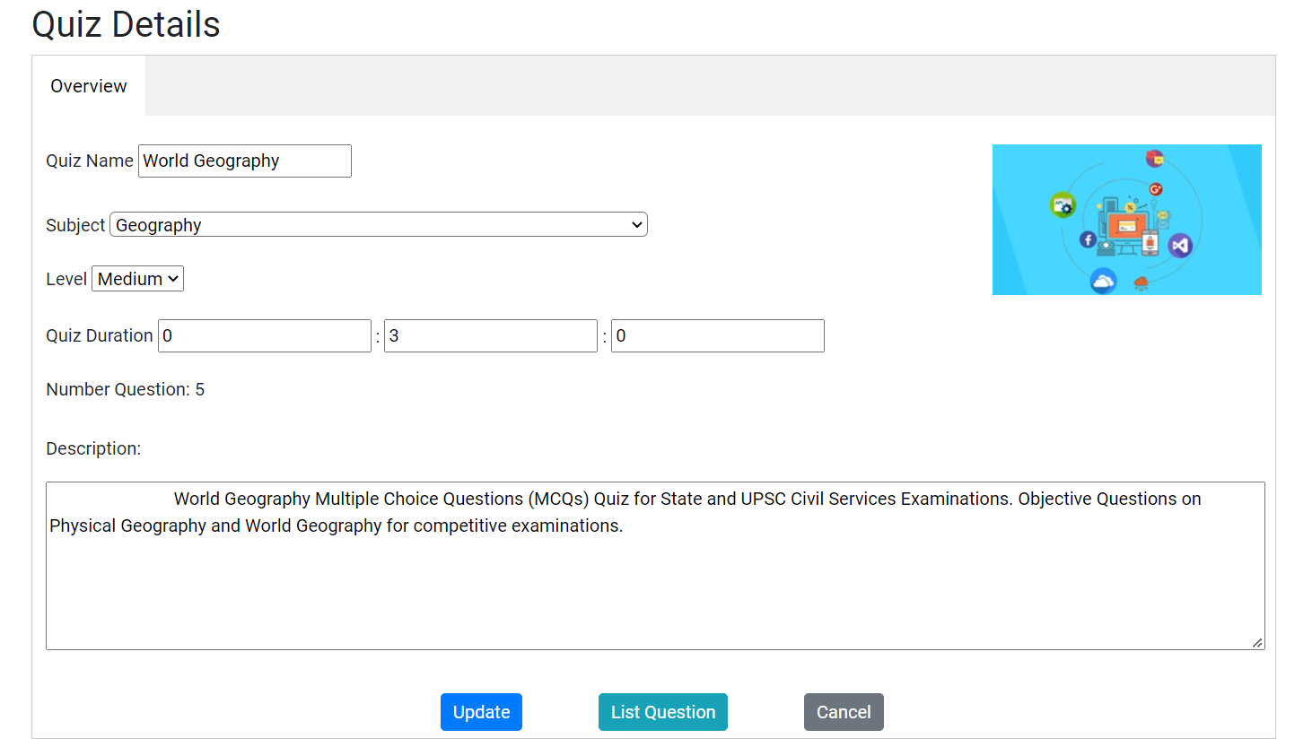

#### 

| **UI Element Description** | | |
| --- | --- | --- |
| ID | 20 | |
| Description | The page allows the Expert to update the information of the quiz | |
| **UI Element Displays** | | |
| **Precondition** | **Display** | |
| The user is logged in and has the role of expert | * Input text to enter name quiz * Combobox to select subject * Combobox to select level * Input to enter hours minutes seconds * Input text to enter description quiz | |
| **UI Element Behaviors** | | |
| **Precondition** | **Action** | **Respond** |
| The user is expert, and click button Cancel | Click button Cancel | System will redirect quiz list Page |
| The user is expert, and click button List question | Click button list question quiz | System will redirect question list Page |
| The user is expert, and click button Update | Click button update quiz | System will redirect quiz list Page |

| **Use Case ID** | UC- 22 |
| --- | --- |
| **Actor** | Expert |
| **Description** | This function allows the expert to information Update quiz |
| **Precondition** | User must log in to the system with the role of expert |
| **Trigger** | User click button Update |
| **Post-Condition** |  |
| **Normal Flow** | 1 Actor: Open Quiz Practice website.  2 System: Displays Home Page.  3 Actor: Click vào “Hello,tên”  4 System: Display dropdown  5 Actor: Click Button Manager  6 System: Display list quiz Page  7 Actor: Click button Update quiz  8 System: Display update quiz Page |
| **Exception** |  |

***d.Delete New Quiz***

| **Use Case ID** | UC- 23 |
| --- | --- |
| **Actor** | Expert |
| **Description** | This function allows the expert to Datele quiz |
| **Precondition** | User must log in to the system with the role of expert |
| **Trigger** | User click button Delete |
| **Post-Condition** |  |
| **Normal Flow** | 1 Actor: Open Quiz Practice website.  2 System: Displays Home Page.  3 Actor: Click vào “Hello,tên”  4 System: Display dropdown  5 Actor: Click Button Manager  6 System: Display list quiz Page  7 Actor: Click button Delete quiz  8 System: Display list quiz Page after delete quiz |
| **Exception** |  |

#### 

## 5. Feature Admin

### a. Management User

| **UI Element: Management User** | | |
| --- | --- | --- |
| **UI Element Description** | | |
| ID | 20 | |
| Description | This screen allows Admin to view detailed information of all users in the system, in addition, there is an add button for admin to add new users and button at action column for admin to block/active user. | |
| **UI Element Displays** | | |
| **Precondition** | **Display** | |
| Users is logged in as Admin | - return button to back to Home page   - display avatar of admin   - display name of admin   - search bar to search for users by username    - a link to redirect to management user page   - a link to redirect to management quiz page   - a link to redirect to management question page   - a link to redirect to management subject page   - a button to add new user | |
| Admin click add button | 1 popup shows fields like:  - A input: text type to enter username  - A input: email type to enter email  - A input: password type to enter password, user-entered passwords will show * instead of clear characters.  - A input: password type to enter confirm password, user-entered passwords will show * instead of clear characters.    - 2 radio buttons to choose gender: Male or Female   - A input: date type to enter date, can select the date without manually entering it by clicking on the calendar icon on the right.  - A combobox to choose role for user.  - Close button to close popups.  - Add button to add. | |
| Admin entered username in input and click search button but no results | - Displays message “No results found for ‘’ !!!” | |
| Admin add new user enter the existing username in the system | - Displays message “This username is already use !!!” | |
| Admin add new user enter the existing email in the system | - Displays message “This email is already use !!!” | |
| Admin add new user enter password does not match confirm password | - Displays message “Password and Confirm Password must be match !” | |
| **UI Element Behaviors** | | |
| **Precondition** | **Action** | **Respond** |
| Users is logged in as Admin | User clicks on return button | System will redirect to Home page |
| Users is logged in as Admin | User clicks manage user button | System will redirect to User Management page |
| Users is logged in as Admin | User clicks on manage quiz button | System will redirect to Quiz Management page |
| Users is logged in as Admin | User clicks on manage question button | System will redirect to Question Management page |
| Users is logged in as Admin | User clicks on manage subject button | System will redirect to Subject Management page |
| Users is logged in as Admin | User clicks on add button | A window appears for admin to enter the fields as username, email, password and confirm password, select gender, dob and role |

| **Use Case ID** | UC-20 |
| --- | --- |
| **Name** | Manage User |
| **Actor** | Admin |
| **Description** | - This function allows Admin to view information of all existing users in the system |
| **Precondition** | - User login to the system as Admin. |
| **Trigger** | - User clicks on their name in the top right corner of the home page and selects manage. |
| **Post-Condition** | - N/A |
| **Normal Flow** | NF-1: 1. Actor: Log in to the system.  2. System: Displays Home Page.  3. Actor: Click on the user's name in the top right corner of the home page header and select 'Manage'  4. System: Displays Management User Page |

#### 

| **Use Case ID** | UC-21 |
| --- | --- |
| **Name** | Search User |
| **Actor** | Admin |
| **Description** | - This function allows Admin to search user by username. |
| **Precondition** | - User login to the system as Admin. |
| **Trigger** | - On the management user page, the user enters the input value and clicks the search button. |
| **Post-Condition** | - N/A |
| **Normal Flow** | NF-1: 1. Actor: Log in to the system.  2. System: Displays Home Page.  3. Actor: Click on the user's name in the top right corner of the home page header and select 'Manage'  4. System: Displays Management User Page 5. Actor: Enter the username of the user they want to find  6. System: Displays the user whose username matches the value entered. |
| **Exception Flow** | EF-1: At step 5 NF-1 1. Actor: Enter the username of the user Admin want to find, but there are no results 2. System: Display message “No Result for ‘...’” |

#### 

| **Use Case ID** | UC-22 |
| --- | --- |
| **Name** | Add User |
| **Actor** | Admin |
| **Description** | - This function allows Admin to add the new user to the system. |
| **Precondition** | - User login to the system as Admin. |
| **Trigger** | - Admin clicks add button on management user page. |
| **Post-Condition** | - The user's information when successfully added will be saved to the database |
| **Normal Flow** | NF-1: 1. Actor: Log in to the system.  2. System: Displays Home Page.  3. Actor: Click on the user's name in the top right corner of the home page header and select 'Manage'  4. System: Displays Management User Page 5. Actor: Click on Add New User button. 6. System: Displays Popups with fields username, email, password, confrim password, gender, dob, role. 7. Actor: Enter username and email that have not been used in the system, password and confirm password match, select gender, dob, role. 8. System: Displays Management User Page |
| **Exception Flow** | EF-1: At step 7 NF-1 1. Actor: Enter the username already used in the system  2. System: Displays message “This username is already used!!!”  EF-2: At step 7 NF-1 1. Actor: Enter the email already used in the system  2. System: Displays message “This email is already used!!!”  EF-3: At step 7 NF-1 1. Actor: Enter password and confirm password do not match  2. System: Displays message “Password and Confirm Password must match!” |

#### 

| **Use Case ID** | UC-23 |
| --- | --- |
| **Name** | Active User |
| **Actor** | Admin |
| **Description** | - This function allows Admin to active a user to the system. |
| **Precondition** | - User login to the system as Admin. - User that admin active must be blocked/not active |
| **Trigger** | - User clicks active button on management user page. |
| **Post-Condition** | - Upon activation, the activated user can login to the system. |
| **Normal Flow** | NF-1: 1. Actor: Log in to the system.  2. System: Displays Home Page.  3. Actor: Click on the user's name in the top right corner of the home page header and select 'Manage'  4. System: Displays Management User Page 5. Actor: Click the active button in the action column to activate or unblock a certain user 6. System: That user's action column goes from active button to block button |

#### 

| **Use Case ID** | UC-24 |
| --- | --- |
| **Name** | Block User |
| **Actor** | Admin |
| **Description** | - This function allows Admin to block a user to the system. |
| **Precondition** | - User login to the system as Admin. - User that admin blocks must be active |
| **Trigger** | - User clicks block button on management user page. |
| **Post-Condition** | - When blocked, users will not be able to log in to the system. |
| **Normal Flow** | NF-1: 1. Actor: Log in to the system.  2. System: Displays Home Page.  3. Actor: Click on the user's name in the top right corner of the home page header and select 'Manage'  4. System: Displays Management User Page 5. Actor: Click the block button in the action column to block a certain user 6. System: That user's action column goes from block button to active button |
| **Exception Flow** | EF-1: At step 5 of NF-1 1. Actor: Click on the block button in the action column of the user whose role is admin  2. System: Displays alertBox ‘Admin cannot block admin.’ |

#### 

#### 

### b. Subject Management

| **UI Element: Subject Management** | | |
| --- | --- | --- |
| **UI Element Description** | | |
| ID | 17 | |
| Description | This function allows Admin to view information of all existing subjects in the system. Besides, it allows admin to manage subjects by updating, deleting and adding | |
| **UI Element Displays** | | |
| **Precondition** | **Display** | |
| Always | Subject Management will be displayed with:   * Search bar:      * List of subjects:      * Add Subject button:      * “Add Subject” page | |
| **UI Element Behaviors** | | |
| **Precondition** | **Action** | **Respond** |
| Users is logged in as Admin | Users click on “” button | System will redirect to Home page |
| Users is logged in as Admin | Users click on “Manage Subject” button | System will redirect to Subject Management page |
| Always | Users click on Search bar | System allows users to search subjects by name |
| Always | Users click on “Add Subject” button | System allows user to add subjects with Name, Image and Description |
| Users click on “Add Subject” button | Users click on “Subject Name” field | System allow user to add Subject Name by inputting text into |
| Users click on “Add Subject” button | Users click on “Chọn tệp” button | System allow users to add image of subjects by selecting in the File Explorer |
| Users click on “Add Subject” button | Users click on Description text area | System allow user to add description of subjects by inputting text into |
| Users click on “Add Subject” button | Users complete all fields and click on “Submit” button | System will add information in the list and database will be updated |
| Always | Users click on “Delete” button | System will delete subjects and database will be updated |
| Always | Users click on “Update” button | System will update information of subjects and update to the database |

| **Use Case ID** | UC-21 |
| --- | --- |
| **Name** | Subject Management |
| **Actor** | Admin |
| **Description** | - This function allows Admin to view information of all existing subjects in the system. Besides, it allows admin to manage subjects by updating, deleting and adding |
| **Precondition** | - User logged in to the system as Admin. |
| **Trigger** | - User clicks on “Admin” button on the navbar |
| **Post-Condition** | - Database will be changed |
| **Normal Flow** | 1. Actor: Click on “Admin” button on the navbar.  2. System: Displays  3. Actor: Click on “Subject Management” button  4. System: Redirect to the Subject Management page  5. Actor: Manage Subject by updating, deleting and adding subjects  6. System: Update to the database |

#### 

### C. Question Management

#### View Question List

**-Question List screen**

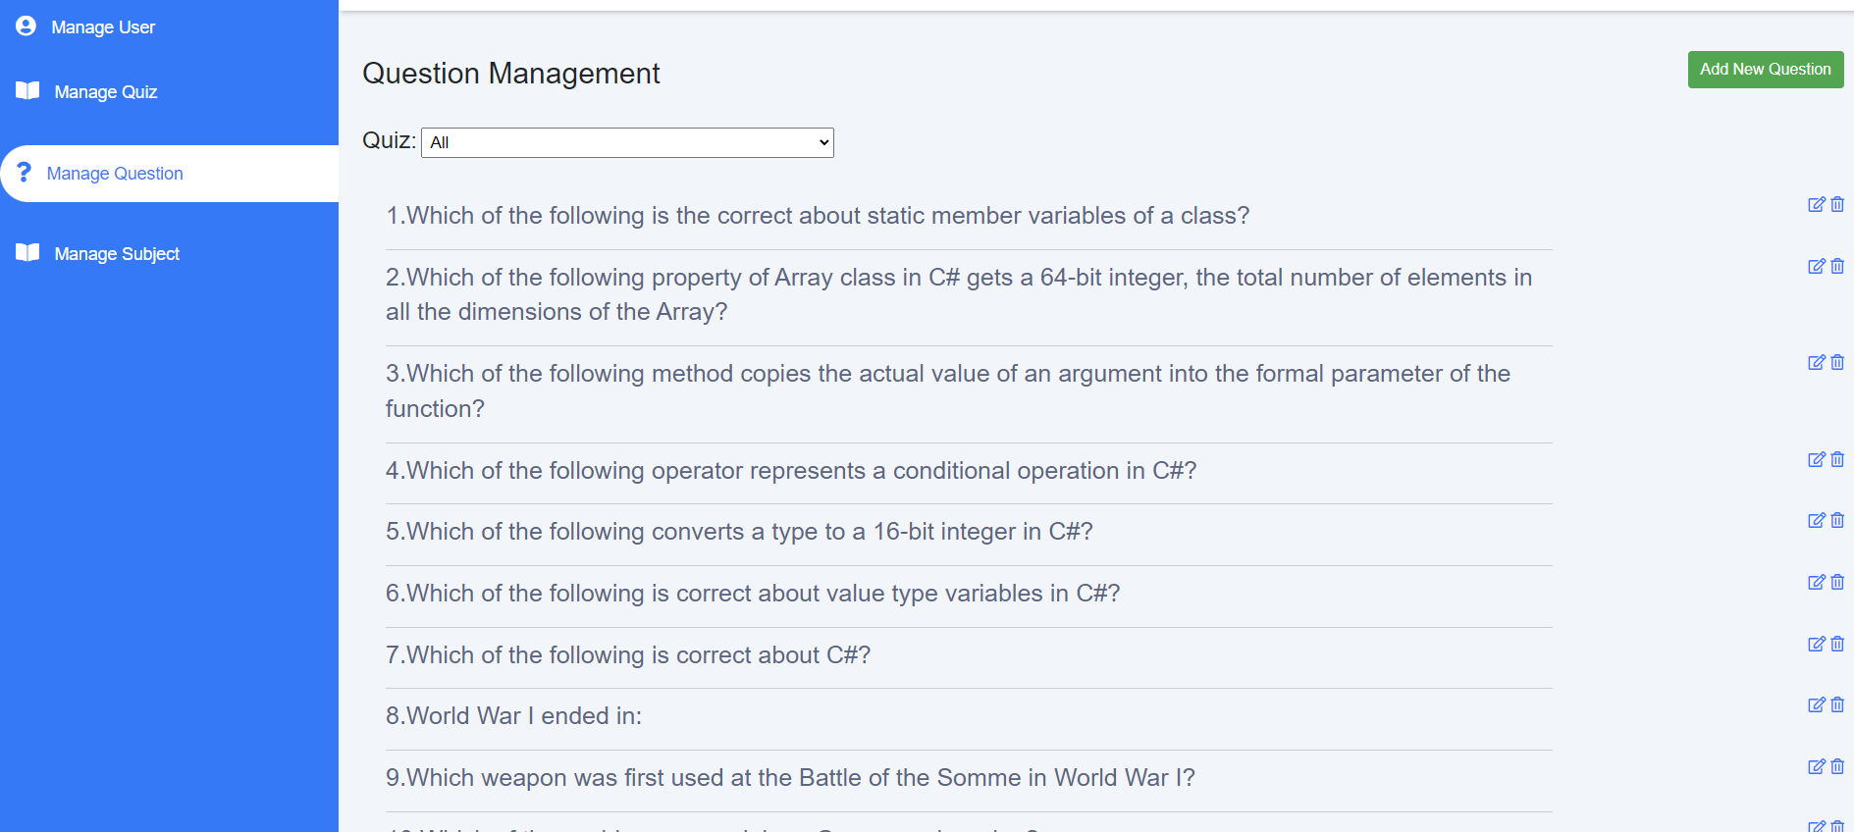

**-Filter Question By Quiz screen**

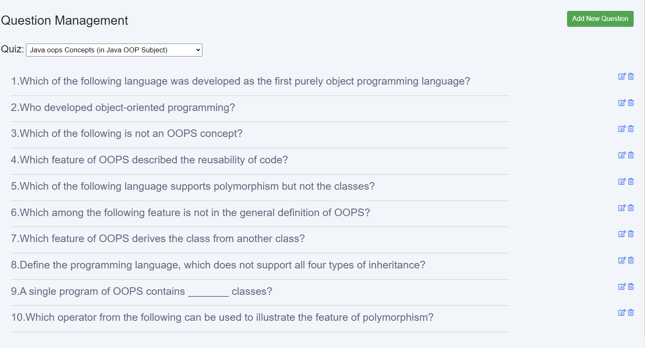

**-Search Question by NameQuestion screen**

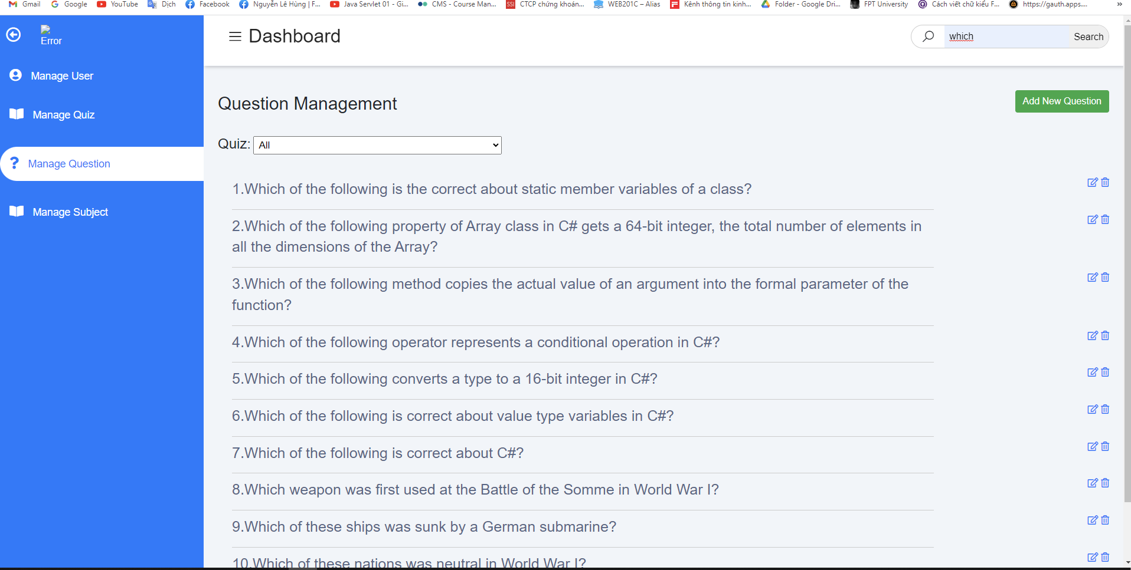

| **UI Element: View Question List** | | |
| --- | --- | --- |
| **UI Element Description** | | |
| ID | 18 | |
| Description | This function allows Admin to see all questions that Expert has created in test and Admin can filter question by question name and search question by name question | |
| **UI Element Displays** | | |
| **Precondition** | **Display** | |
| Always | Page display question list  Include Question name:    Filter Quiz bar:    Paging:    button add, update , delete button:      - return button to back to Home page  - search bar to search for Question by Question Name  - a link to redirect to management user page   - a link to redirect to management quiz page   - a link to redirect to management question page   - a link to redirect to management subject page | |
| Admin click on any Quiz | The screen will show “All Questions filtered by that Quiz!” | |
| Admin click button Search and Search any question name | The screen will show “all questions were found by Question Name!” | |
| Admin search Question but question don’t have in system | The screen will show “No results found for “Value Searched”” | |
| **UI Element Behaviors** | | |
| **Precondition** | **Action** | **Respond** |
| Admin is logged in | Admin clicks back button | System will redirect to Dashboard page |
| Admin is logged in | Admin clicks cancel button on add question screen | System will redirect to Management question page |
| Admin is logged in | Admin clicks Add button on add question screen | System will redirect to Management question page |
| Admin is logged in | Admin clicks back button on Edit Question screen | System will redirect to Management question page |
| Admin is logged in | Admin clicks Edit button on Edit Question screen | System will redirect to Management question page |

| **Use Case ID** | UC-22 |
| --- | --- |
| **Name** | Views Question List |
| **Actor** | Admin |
| **Description** | This function allows the Admin to view all the questions Expert or Admin has created in the quiz |
| **Precondition** | -User must be an Admin  -Expert or Admin created the questions |
| **Trigger** | - Admin clicks the Manager Question button on the Manager User HomePage |
| **Post-Condition** | .Admin has logged into the system |
| **Normal Flow** | 1.Actor: Click on the user's name in the top right corner of the home page header and select 'Manage'  2. System: display Manager User page  3.Actor: Click the Manager Question button on the Manager User page.  4. System: Displays the Management Question Page of Admin |

#### 

| **Use Case ID** | UC-23 |
| --- | --- |
| **Name** | Filter Question By Quiz |
| **Actor** | Admin |
| **Description** | This function allows the Admin to Filter question By Quiz |
| **Precondition** | -User must be an Admin  -Admin want filter question |
| **Trigger** | - Admin clicks and select any Quiz on the Quiz Bar at the Management Question Page |
| **Post-Condition** | .Admin has logged into the system |
| **Normal Flow** | 1.Actor: Click the Manager button on the Home page  2. System: display Manager User page  3.Actor: Click the Manager Question button on the Manager User page.  4. System: Displays the Management Question Page of Admin  5.Actor: Click any quiz button on quiz bar  6.System: Display Filtered question by that Quiz |

| **Use Case ID** | UC-24 |
| --- | --- |
| **Name** | Search Question By Question Name |
| **Actor** | Admin |
| **Description** | This function allows the Admin to Search Question By Question Name |
| **Precondition** | -User must be an Admin  -Admin Want search Question |
| **Trigger** | - Admin clicks Question button and Enter the question you want to search at the Management Question Page |
| **Post-Condition** | .Admin has logged into the system |
| **Normal Flow** | 1.Actor: Click the Manager button on the Home page  2. System: display Manager User page  3.Actor: Click the Manager Question button on the Manager User page.  4. System: Displays the Management Question Page of Admin  5.Actor: Click search button and Enter the question you want to search at the management question page  6.System: if the question is in the system , Display all question searched |
| **Exception Flow** | 1.Actor: Click search button and Enter the question you want to search at the management question page  2.System: if the question is not in the system , Display No results found for + “value searched”“ |

#### Add New Question

**-Add new Question screen**

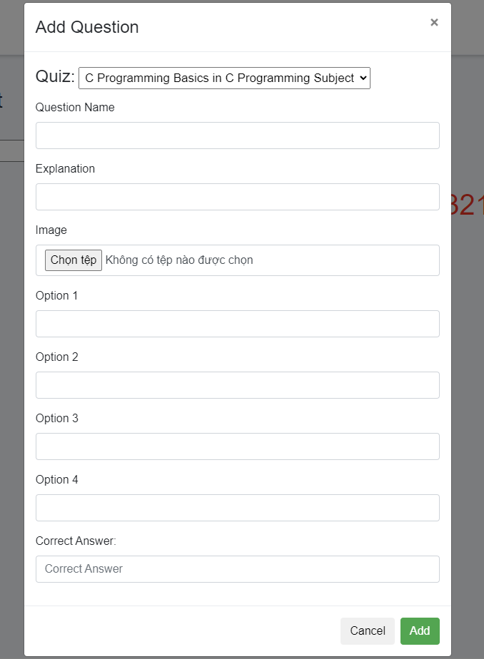

**-Screen when question information is blank**

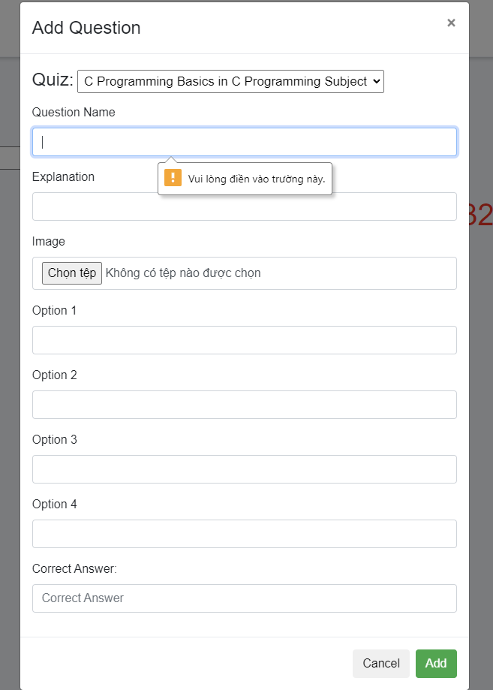

**-screen when you choose the correct answer not between (1 -> 4)**

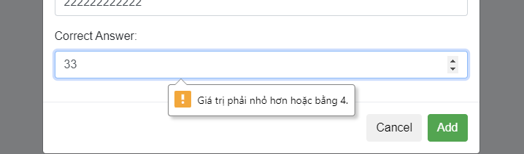

| **UI Element: Add New Question** | | |
| --- | --- | --- |
| **UI Element Description** | | |
| ID | 19 | |
| Description | This function allows Admin to add new questions to the existing Quiz in the system | |
| **UI Element Displays** | | |
| **Precondition** | **Display** | |
| Alway | Quiz Bar:    Question input:    Explanation Input:    Option Input:    Answer Correct Input:    Button Cancel:    Button Add: | |
| If one of the information input fields is left blank | The screen will show : | |
| When admin chooses the correct answer more than 4 | The screen will show : | |
| When admin chooses the correct answer left than 1 | The screen will show : | |
| **UI Element Behaviors** | | |
| **Precondition** | **Action** | **Respond** |
| Admin is logged in | Admin clicks Cancel button | System will redirect to Management Question page |
| Admin is logged in | Admin clicks Add button | System will redirect to Management Question page |

| **Use Case ID** | UC-25 |
| --- | --- |
| **Name** | Add New Question |
| **Actor** | Admin |
| **Description** | This function allows the Admin to add new question to quiz |
| **Precondition** | -User must be an Admin  -Admin wants to add new question |
| **Trigger** | - Admin clicks the add new question button on the Manager Question HomePage |
| **Post-Condition** | .Admin has logged into the system |
| **Normal Flow** | 1.Actor: Click on the user's name in the top right corner of the home page header and select 'Manage'  2. System: display Management User page  3.Actor: Click the Manager Question button on the Manager User page.  4. System: Displays the Management Question Page of Admin  5.Actor: Click the add new question button  6.Display: Add Question screen  7.Admin enter into all fields information and click add  8.Display: Display Management Question Page |
| **Exception Flow** | 1.Actor: Admin leave 1 in all fields blank  2. System:Display “Vui Lòng Điền Vào Trường Này”  3.Actor: Admin enter correct answer greater than 4  4.System: Display “ Giá trị phải nhỏ hơn hoặc bằng 4 “  5.Actor: Admin enter correct answer left than 1  6.System: Display “ Giá trị phải Lớn hơn hoặc bằng 1 “ |

#### 

#### Update Question

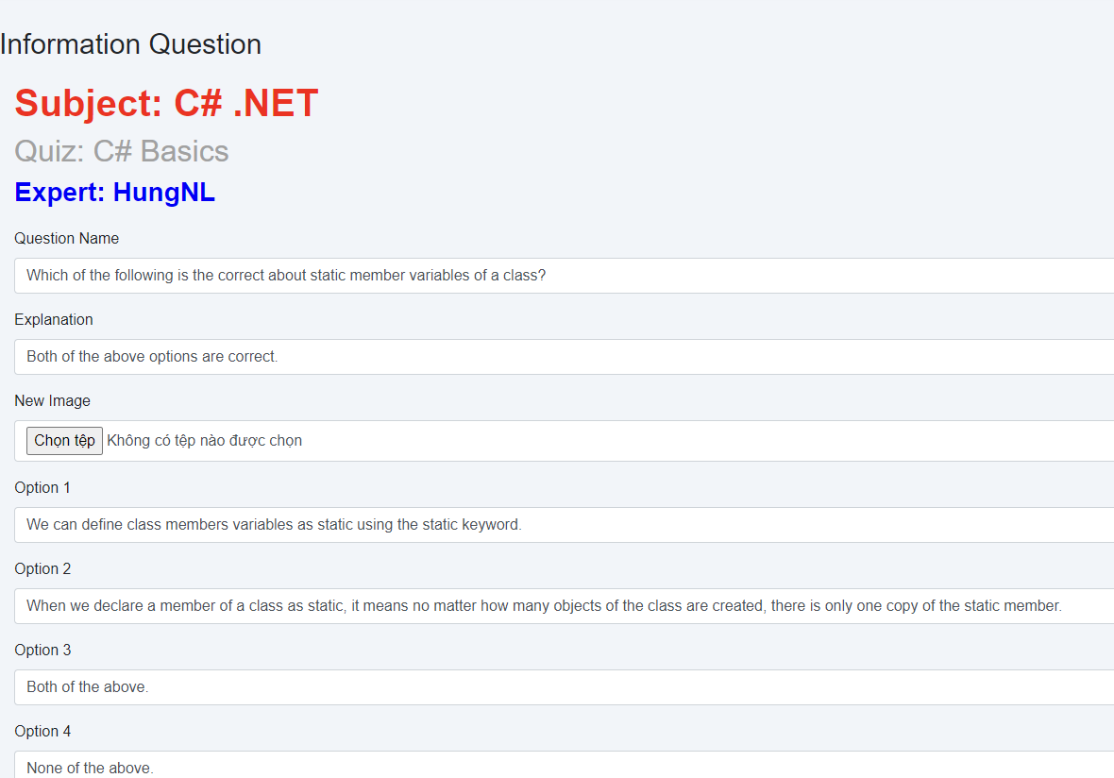

| **UI Element: Update Question** | | |
| --- | --- | --- |
| **UI Element Description** | | |
| ID | 20 | |
| Description | This function allows Admin to Edit questions to the existing Quiz in the system | |
| **UI Element Displays** | | |
| **Precondition** | **Display** | |
| Alway | Subject Name:  Quiz Name:    Expert Name:    Question Name:    Explanation Name:    Option Name:    Answer Correct Input:    Button Back:    Button Edit: | |
| If one of the information input fields is left blank | The screen will show : | |
| When admin chooses the correct answer more than 4 | The screen will show : | |
| When admin chooses the correct answer left than 1 | The screen will show : | |
| **UI Element Behaviors** | | |
| **Precondition** | **Action** | **Respond** |
| Admin is logged in | Admin clicks Back button | System will redirect to Management Question page |
| Admin is logged in | Admin clicks Edit button | System will redirect to Management Question page |

| **Use Case ID** | UC-26 |
| --- | --- |
| **Name** | Update Question |
| **Actor** | Admin |
| **Description** | This function allows the Admin edit question created |
| **Precondition** | -User must be an Admin  -Admin wants to edit question |
| **Trigger** | - Admin clicks the update button on the Manager Question HomePage |
| **Post-Condition** | .Admin has logged into the system |
| **Normal Flow** | 1.Actor: Click on the user's name in the top right corner of the home page header and select 'Manage'  2. System: display Management User page  3.Actor: Click the Manager Question button on the Manager User page.  4. System: Displays the Management Question Page of Admin  5.Actor: Click the Edit question button  6.Display: Edit screen  7.Admin enter into all fields information and click edit  8.Display: Display Management Question Page |
| **Exception Flow** | 1.Actor: Admin leave 1 in all fields blank  2. System:Display “Vui Lòng Điền Vào Trường Này”  3.Actor: Admin enter correct answer greater than 4  4.System: Display “ Giá trị phải nhỏ hơn hoặc bằng 4 “  5.Actor: Admin enter correct answer left than 1  6.System: Display “ Giá trị phải Lớn hơn hoặc bằng 1 “ |

#### 

#### Delete Question

| **Use Case ID** | UC-27 |
| --- | --- |
| **Name** | Delete Question |
| **Actor** | Admin |
| **Description** | This function allows the Admin delete question created |
| **Precondition** | -User must be an Admin  -Admin wants to delete question |
| **Trigger** | - Admin clicks the delete button on the Manager Question HomePage |
| **Post-Condition** | .Admin has logged into the system |
| **Normal Flow** | 1.Actor: Click the Manager button on the Home page  2. System: display Management User page  3.Actor: Click the Manager Question button on the Manager User page.  4. System: Displays the Management Question Page of Admin  5.Actor: Click the Delete question button  6.Display: Display Management Question page |

### D. Quiz Management

***a.View Quiz List***

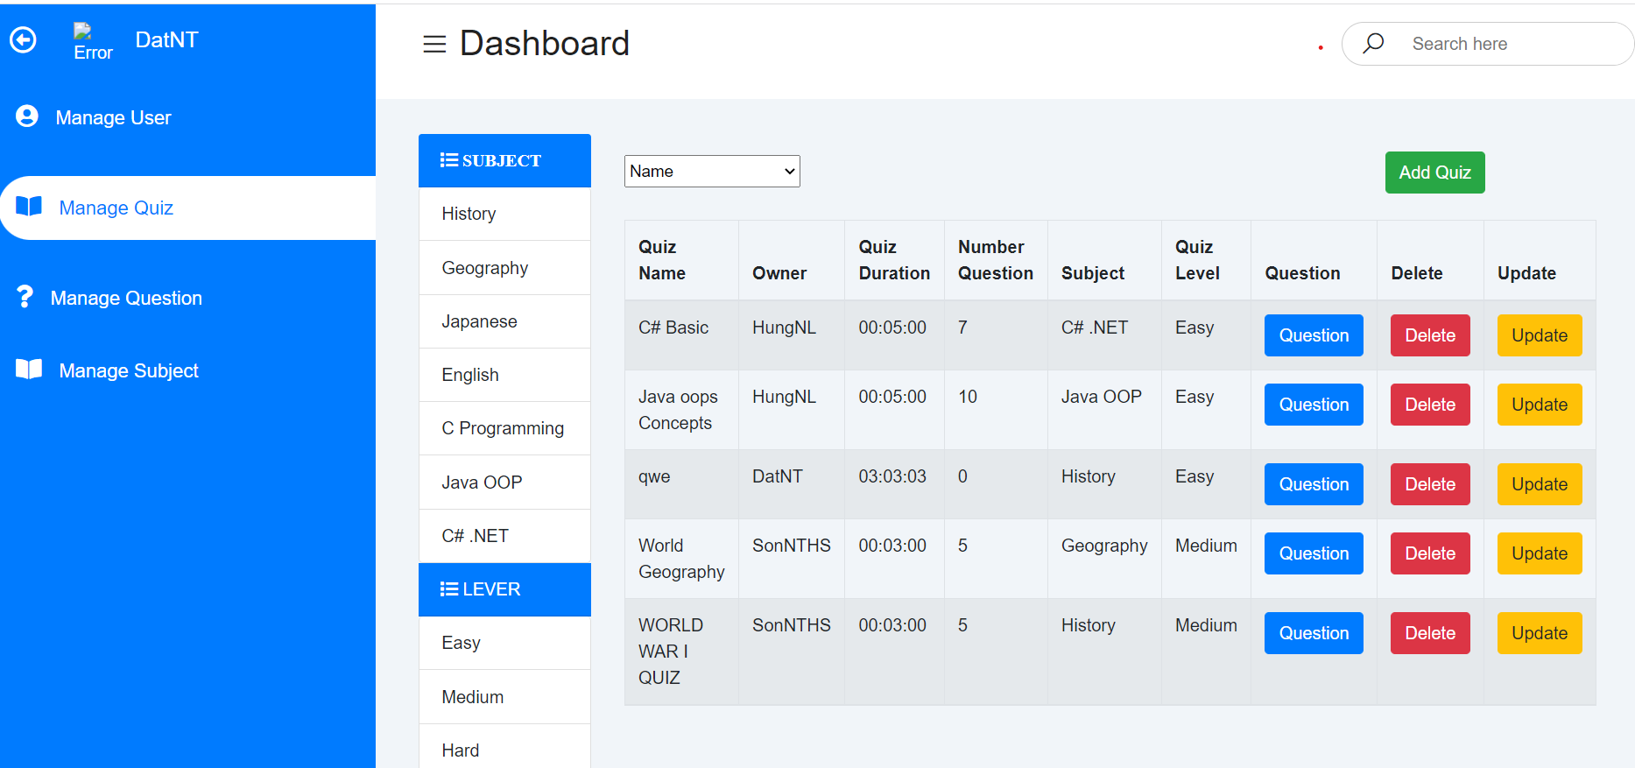

#### 

| **UI Element: Quiz Management** | | |
| --- | --- | --- |
| **UI Element Description** | | |
| ID | 18 | |
| Description | The page displays quizzes that admin users create and can add, edit and delete Quiz, quiz information | |
| **UI Element Displays** | | |
| **Precondition** | **Display** | |
| The user is logged in and has the role of admin | * Button add quiz * Button Question * Button Delete * Button Update * Combobox option: Name, Quiz Duration, Number of Question * Buttons subject name * Button level * Button owner * Information Quiz * Button Manage quiz * Button Manage subject * Button Manage question * Button Manage user | |
| **UI Element Behaviors** | | |
| **Precondition** | **Action** | **Respond** |
| The user is admin, and click button Add quiz | Click button Add quiz | System will redirect Add quiz admin Page |
| The user is admin, and click button Update quiz | Click button Update quiz | System will redirect Update quiz admin Page |
| The user is admin, and click button Delete quiz | Click button Delete quiz | System will redirect list quiz admin Page without quiz deleted |
| The user is admin, and click choose subject | Click choose subject | The system shows quizzes belonging to the subject |
| The user is admin , and click choose level | Click choose level | The system shows quizzes whose level is equal to the selected level |
| The user is admin , and click choose ơner | Click choose owner | The system shows quiz is owned by the selected owner |
| The user is admin, and choose attribute to sort | Click choose attribute to sort | Click on properties to sort quiz |
| The user is admin, and click button Manage quiz | Click button Manage quiz | System will redirect List quiz admin Page |
| The user is admin, and click button Manage user | Click button Manage user | System will redirect List user admin Page |
| The user is admin, and click button Manage question | Click button Manage question | System will redirect List question admin Page |

| **Use Case ID** | UC- 28 |
| --- | --- |
| **Actor** | Admin |
| **Description** | This function allows the admin to see the information of the quiz that the expert owns, sort users by: name , quiz duration, number of question , filter courses by subject, level, owner |
| **Precondition** | User must log in to the system with the role of admin |
| **Trigger** | User click button Manage |
| **Post-Condition** |  |
| **Normal Flow** | 1 Actor: Open Quiz Practice website.  2 System: Displays Home Page.  3 Actor: Click vào “Hello,tên”  4 System: Display dropdown  5 Actor: Click Button Manager  6 System: Display list quiz admin Page |

#### 

***b.Add New Quiz***

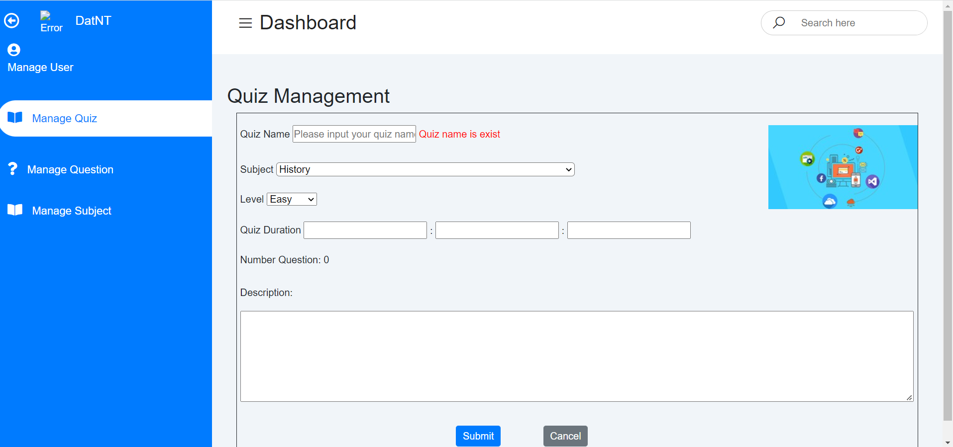

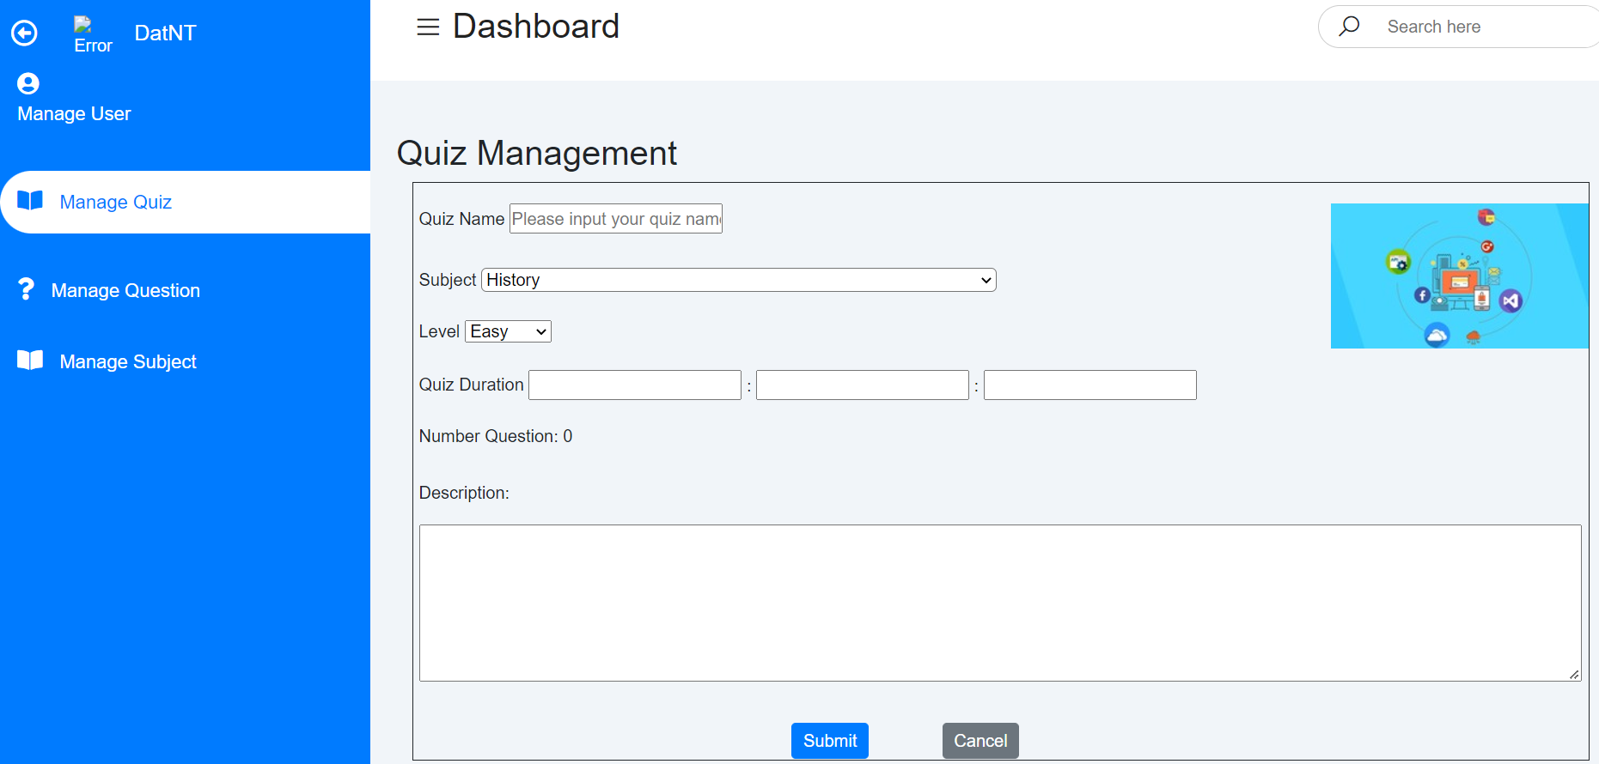

#### 

| **UI Element Description** | | |
| --- | --- | --- |
| ID | 19 | |
| Description | The page allows the Admin to enter the information of the quiz you want to create | |
| **UI Element Displays** | | |
| **Precondition** | **Display** | |
| The user is logged in and has the role of admin | * Input text to enter name quiz * Combobox to select subject * Combobox to select level * Input to enter hours minutes seconds * Input text to enter description quiz * Button Manage quiz * Button Manage subject * Button Manage question * Button Manage user | |
| The user is logged in and has the role of admin and the name entered is the same as the existing quiz name | * Input text to enter name quiz * Combobox to select subject * Combobox to select level * Input to enter hours minutes seconds * Input text to enter description quiz * Message “Quiz name is exist “ * Button Manage quiz * Button Manage subject * Button Manage question * Button Manage user | |
| **UI Element Behaviors** | | |
| **Precondition** | **Action** | **Respond** |
| The user is admin, and click button Cancel | Click button Cancel | System will redirect quiz list admin Page |
| The user is admin, and click button submit | Click button submit quiz | System will redirect quiz list admin Page |
| The user is admin, and click button Manage quiz | Click button Manage quiz | System will redirect List quiz admin Page |
| The user is admin, and click button Manage user | Click button Manage user | System will redirect List user admin Page |
| The user is admin, and click button Manage question | Click button Manage question | System will redirect List question admin Page |

| **Use Case ID** | UC- 29 |
| --- | --- |
| **Actor** | Admin |
| **Description** | This function allows the admin to information new quiz |
| **Precondition** | User must log in to the system with the role of admin |
| **Trigger** | User click button Add quiz |
| **Post-Condition** |  |
| **Normal Flow** | 1 Actor: Open Quiz Practice website.  2 System: Displays Home Page.  3 Actor: Click vào “Hello,tên”  4 System: Display dropdown  5 Actor: Click Button Manager  6 System: Display list quiz Page  7 Actor: Click button Add quiz  8 System: Display add quiz admin Page |
| **Exception** |  |

***c.Update New Quiz***

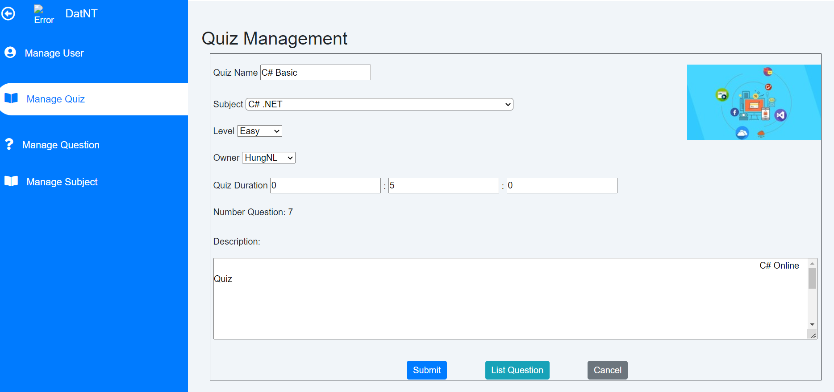

#### 

| **UI Element Description** | | |
| --- | --- | --- |
| ID | 20 | |
| Description | The page allows the Admin to update the information of the quiz | |
| **UI Element Displays** | | |
| **Precondition** | **Display** | |
| The user is logged in and has the role of admin | * Input text to enter name quiz * Combobox to select subject * Combobox to select level * Input to enter hours minutes seconds * Input text to enter description quiz * Button Manage quiz * Button Manage subject * Button Manage question * Button Manage user | |
| **UI Element Behaviors** | | |
| **Precondition** | **Action** | **Respond** |
| The user is admin, and click button Cancel | Click button Cancel | System will redirect quiz list admin Page |
| The user is admin, and click button List question | Click button list question quiz | System will redirect question list Page |
| The user is expert, and click button Update | Click button update quiz | System will redirect quiz list admin Page |
| The user is admin, and click button Manage quiz | Click button Manage quiz | System will redirect List quiz admin Page |
| The user is admin, and click button Manage user | Click button Manage user | System will redirect List user admin Page |
| The user is admin, and click button Manage question | Click button Manage question | System will redirect List question admin Page |

| **Use Case ID** | UC- 30 |
| --- | --- |
| **Actor** | Admin |
| **Description** | This function allows the admin to information Update quiz |
| **Precondition** | User must log in to the system with the role of admin |
| **Trigger** | User click button Update |
| **Post-Condition** |  |
| **Normal Flow** | 1 Actor: Open Quiz Practice website.  2 System: Displays Home Page.  3 Actor: Click vào “Hello,tên”  4 System: Display dropdown  5 Actor: Click Button Manager  6 System: Display list quiz Page  7 Actor: Click button Update quiz  8 System: Display update quiz Page |
| **Exception** |  |

***d.Delete New Quiz***

| **Use Case ID** | UC- 31 |
| --- | --- |
| **Actor** | Admin |
| **Description** | This function allows the admin to Delete quiz |
| **Precondition** | User must log in to the system with the role of admin |
| **Trigger** | User click button Delete |
| **Post-Condition** |  |
| **Normal Flow** | 1 Actor: Open Quiz Practice website.  2 System: Displays Home Page.  3 Actor: Click vào “Hello,tên”  4 System: Display dropdown  5 Actor: Click Button Manager  6 System: Display list quiz Page  7 Actor: Click button Delete quiz  8 System: Display list quiz Page after delete quiz |
| **Exception** |  |